Current Sweep Comparison at -100 kV: 2 mA, 10 mA, 100 mA, 1 A, 10 A, 50 A
Parameters held constant: -100 kV cathode, deuterium ions and electrons in matched currents, 800K particles each, h=0.3mm mesh, j<=20 cap, convergence: 3 consecutive iterations below 100 V epot_max_error.

1. Overview
Run | Current | K = I/V^(3/2) | Converged | Iters to converge | Final epot err (V) | Avg ion traj steps | V(r=0) final (V) | Anode height (%)
run18 | 2 mA | 0.002 | Y | 2 | 0.0000 | 81842059 | -93136.10 | 6.8639
run19 | 10 mA | 0.01 | Y | 2 | 0.0000 | 81709659 | -93136.10 | 6.8639
run20 | 100 mA | 0.1 | Y | 2 | 0.0000 | 81734004 | -93136.10 | 6.8639
run21 | 1 A | 1 | Y | 3 | 0.0000 | 81739496 | -93145.40 | 6.8546
run22 | 10 A | 10 | Y | 3 | 2.9353 | 82790070 | -93240.10 | 6.7599
run23 | 50 A | 50 | Y | 4 | 13.7075 | 88906693 | -93631.00 | 6.3690

2. Superimposed Radial Potential Profiles (x, y, z)
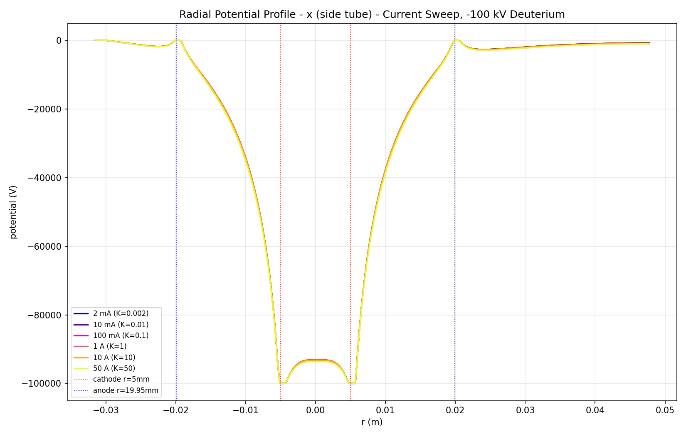
x (side tube) axis - final iter per run, colored by current (plasma)
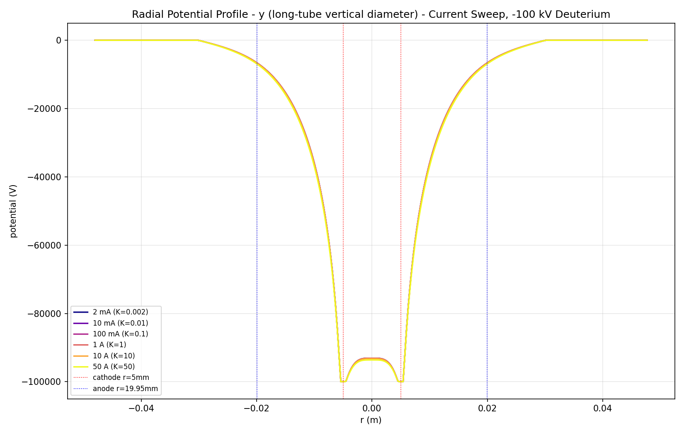
y (long-tube vertical diameter) axis - final iter per run, colored by current (plasma)
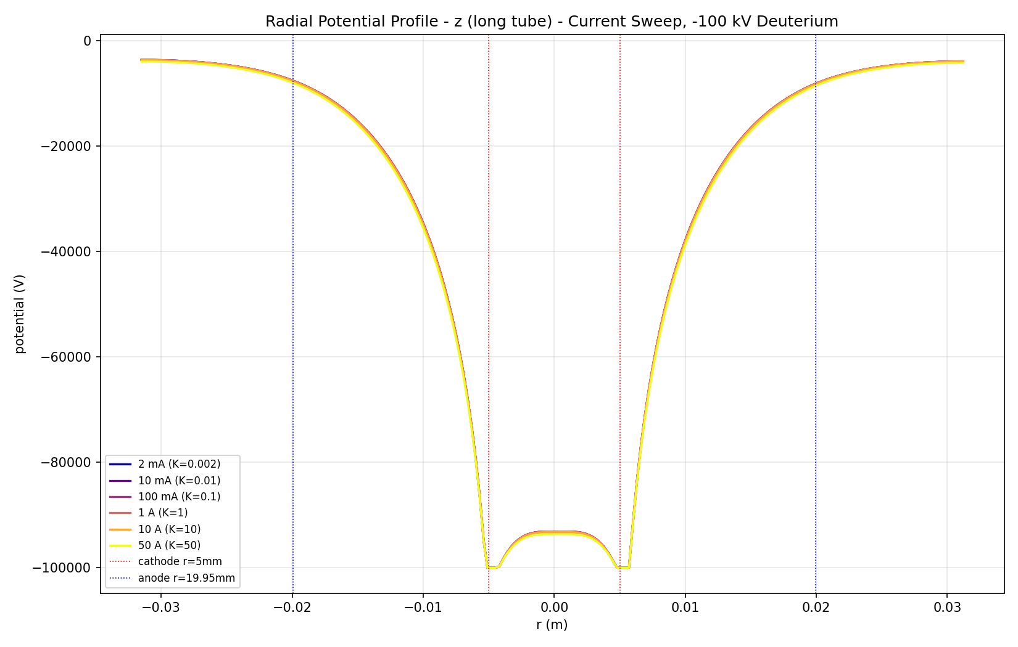
z (long tube) axis - final iter per run, colored by current (plasma)

3. Virtual Anode Height vs Perveance (KEY PHYSICS)
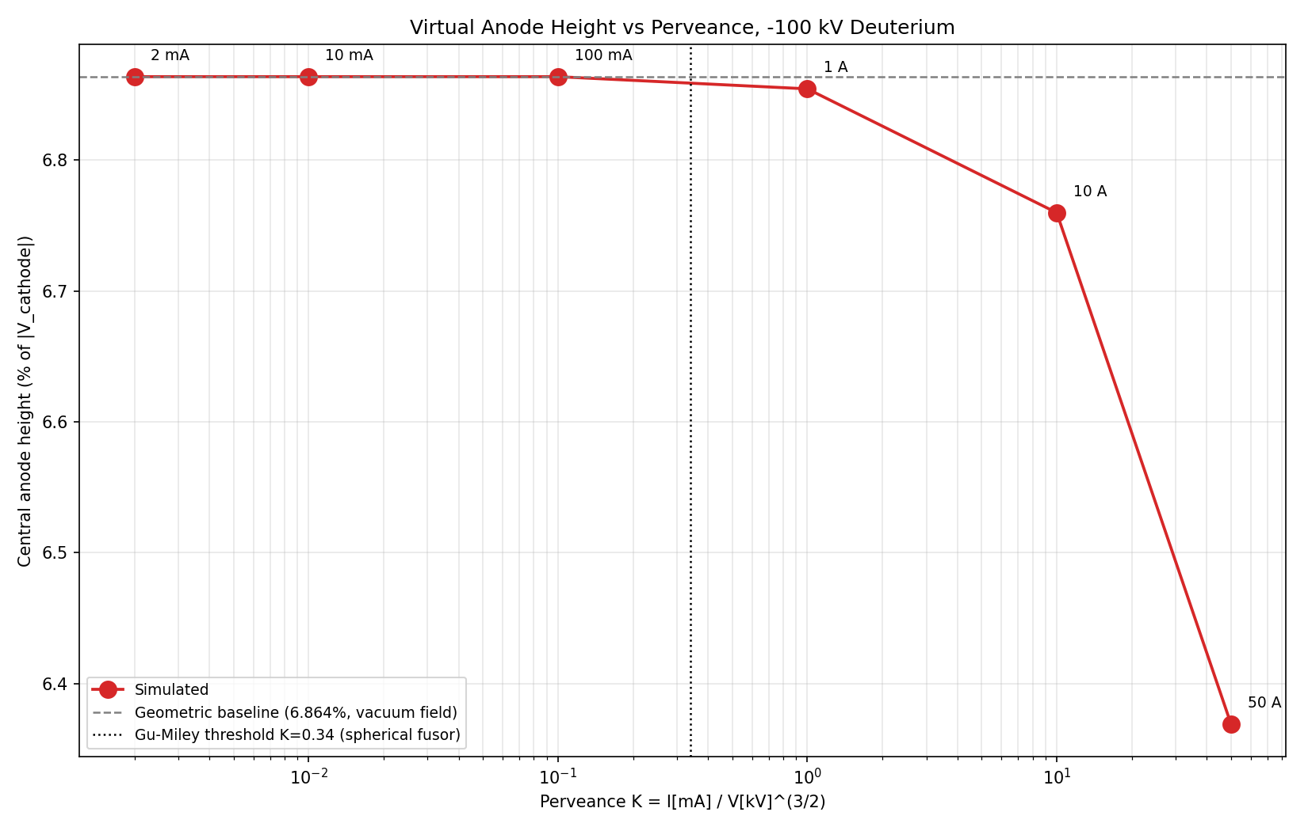
Anode height = (|V_cathode| - |V(r=0)|) / |V_cathode|. Dashed grey line = 6.864% geometric baseline (vacuum / no-space-charge limit, from voltage sweep). Dotted vertical = Gu & Miley (2000) threshold for virtual-anode formation in a fully spherical fusor; our tee geometry pushes the effective threshold much higher because ions escape into side tubes before central space-charge can build up.

4. Superimposed Convergence
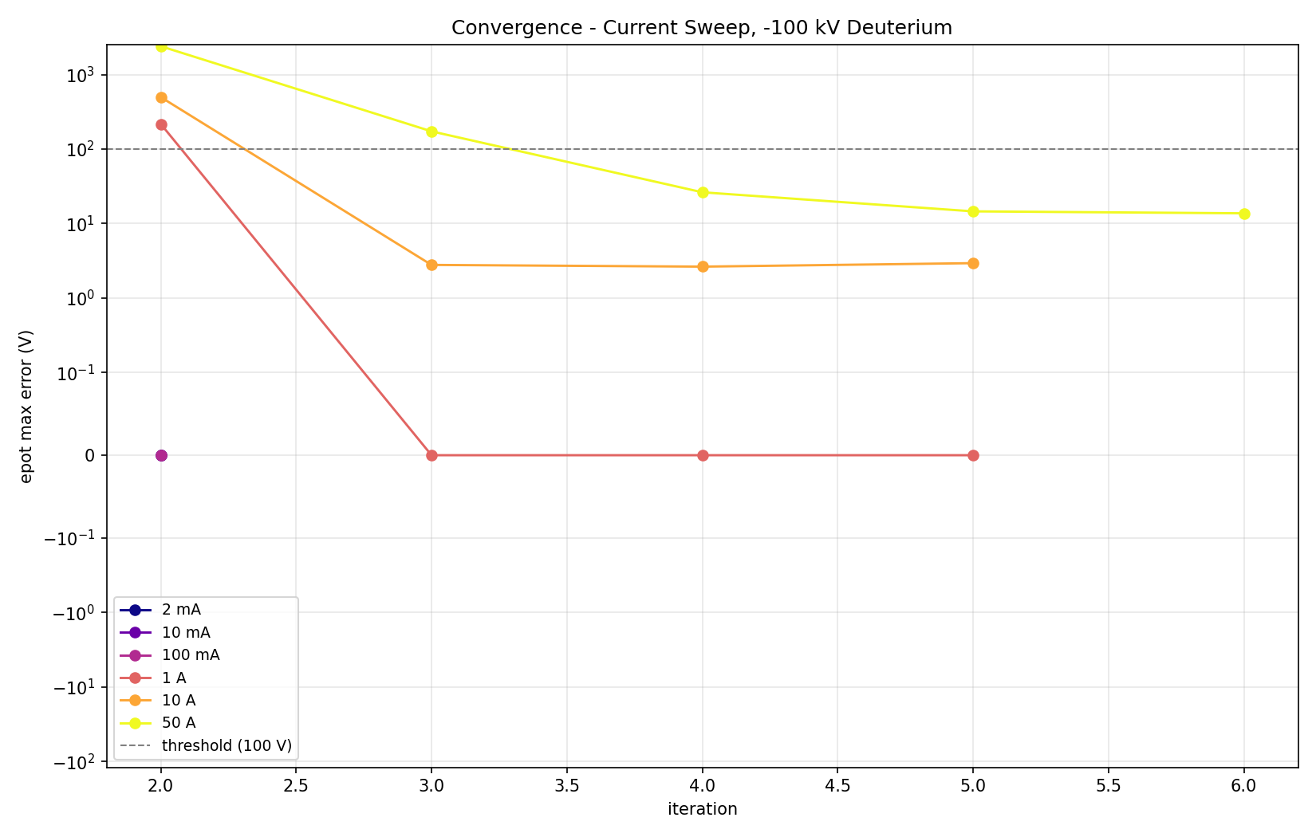

5. Trajectory Density Comparison (XZ slice)

5.1 Ions
2 mA  [missing: voltage sweep runs/run18/trajdens_ions_xz.png] | 10 mA  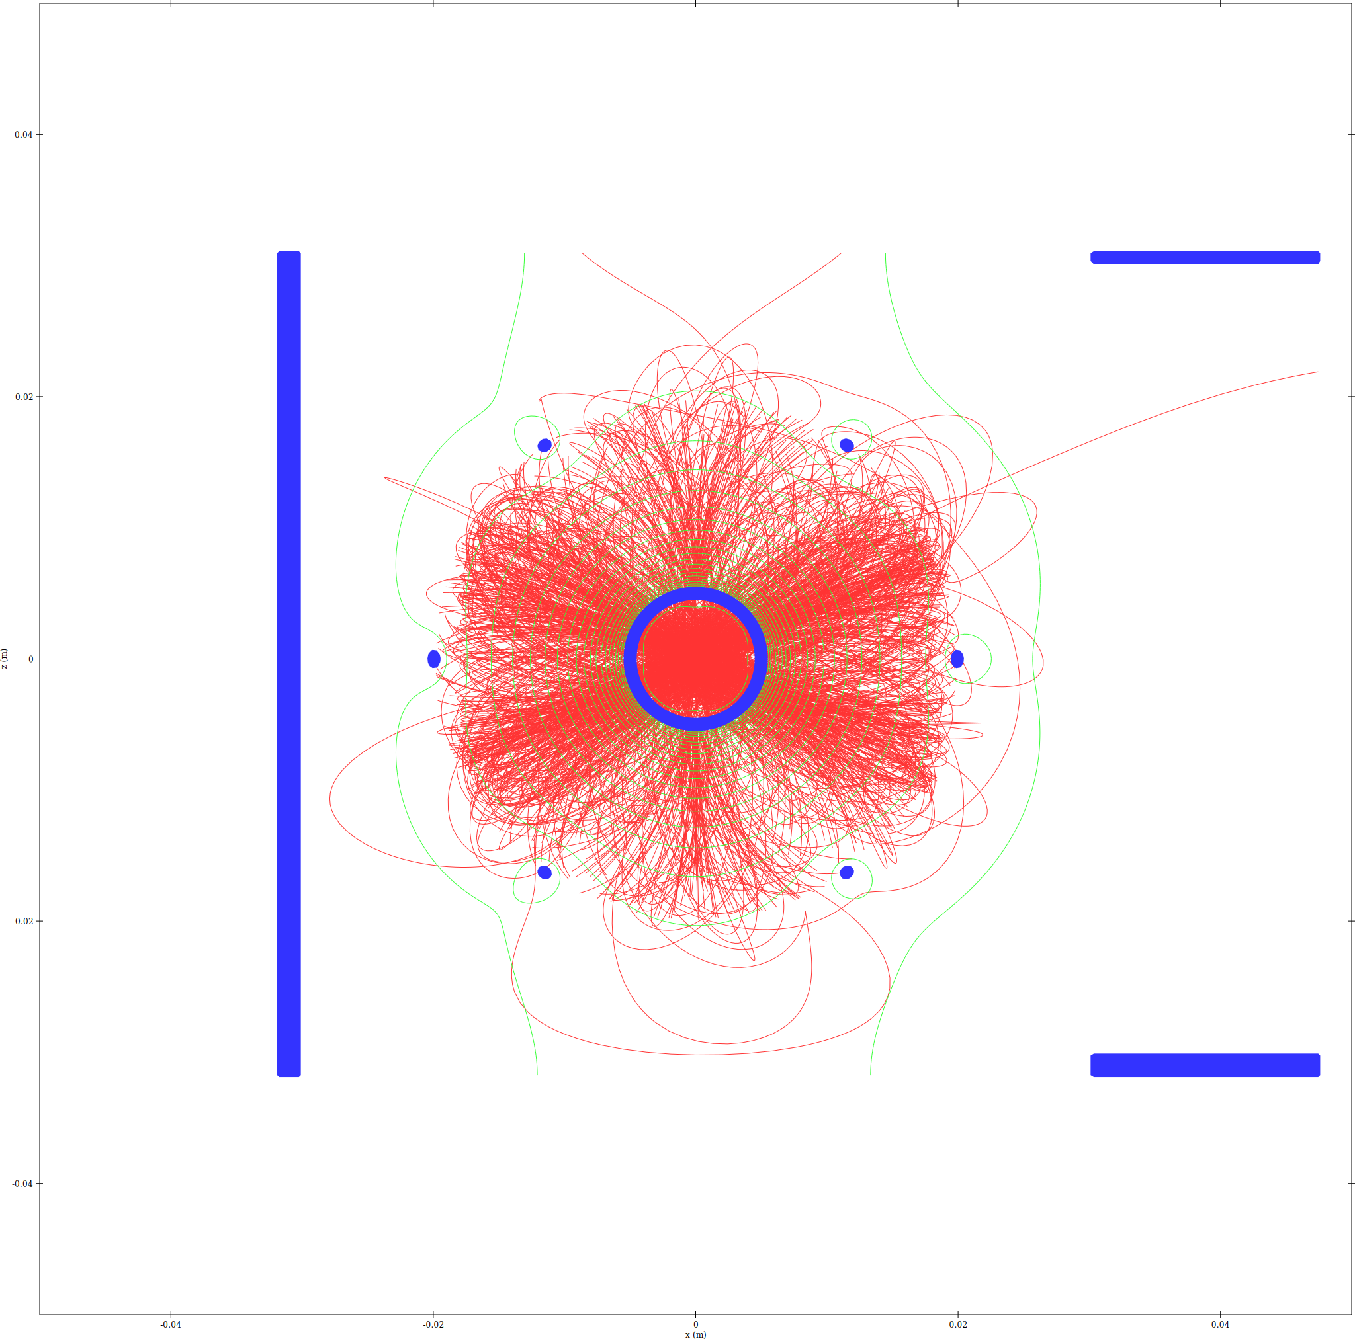
100 mA  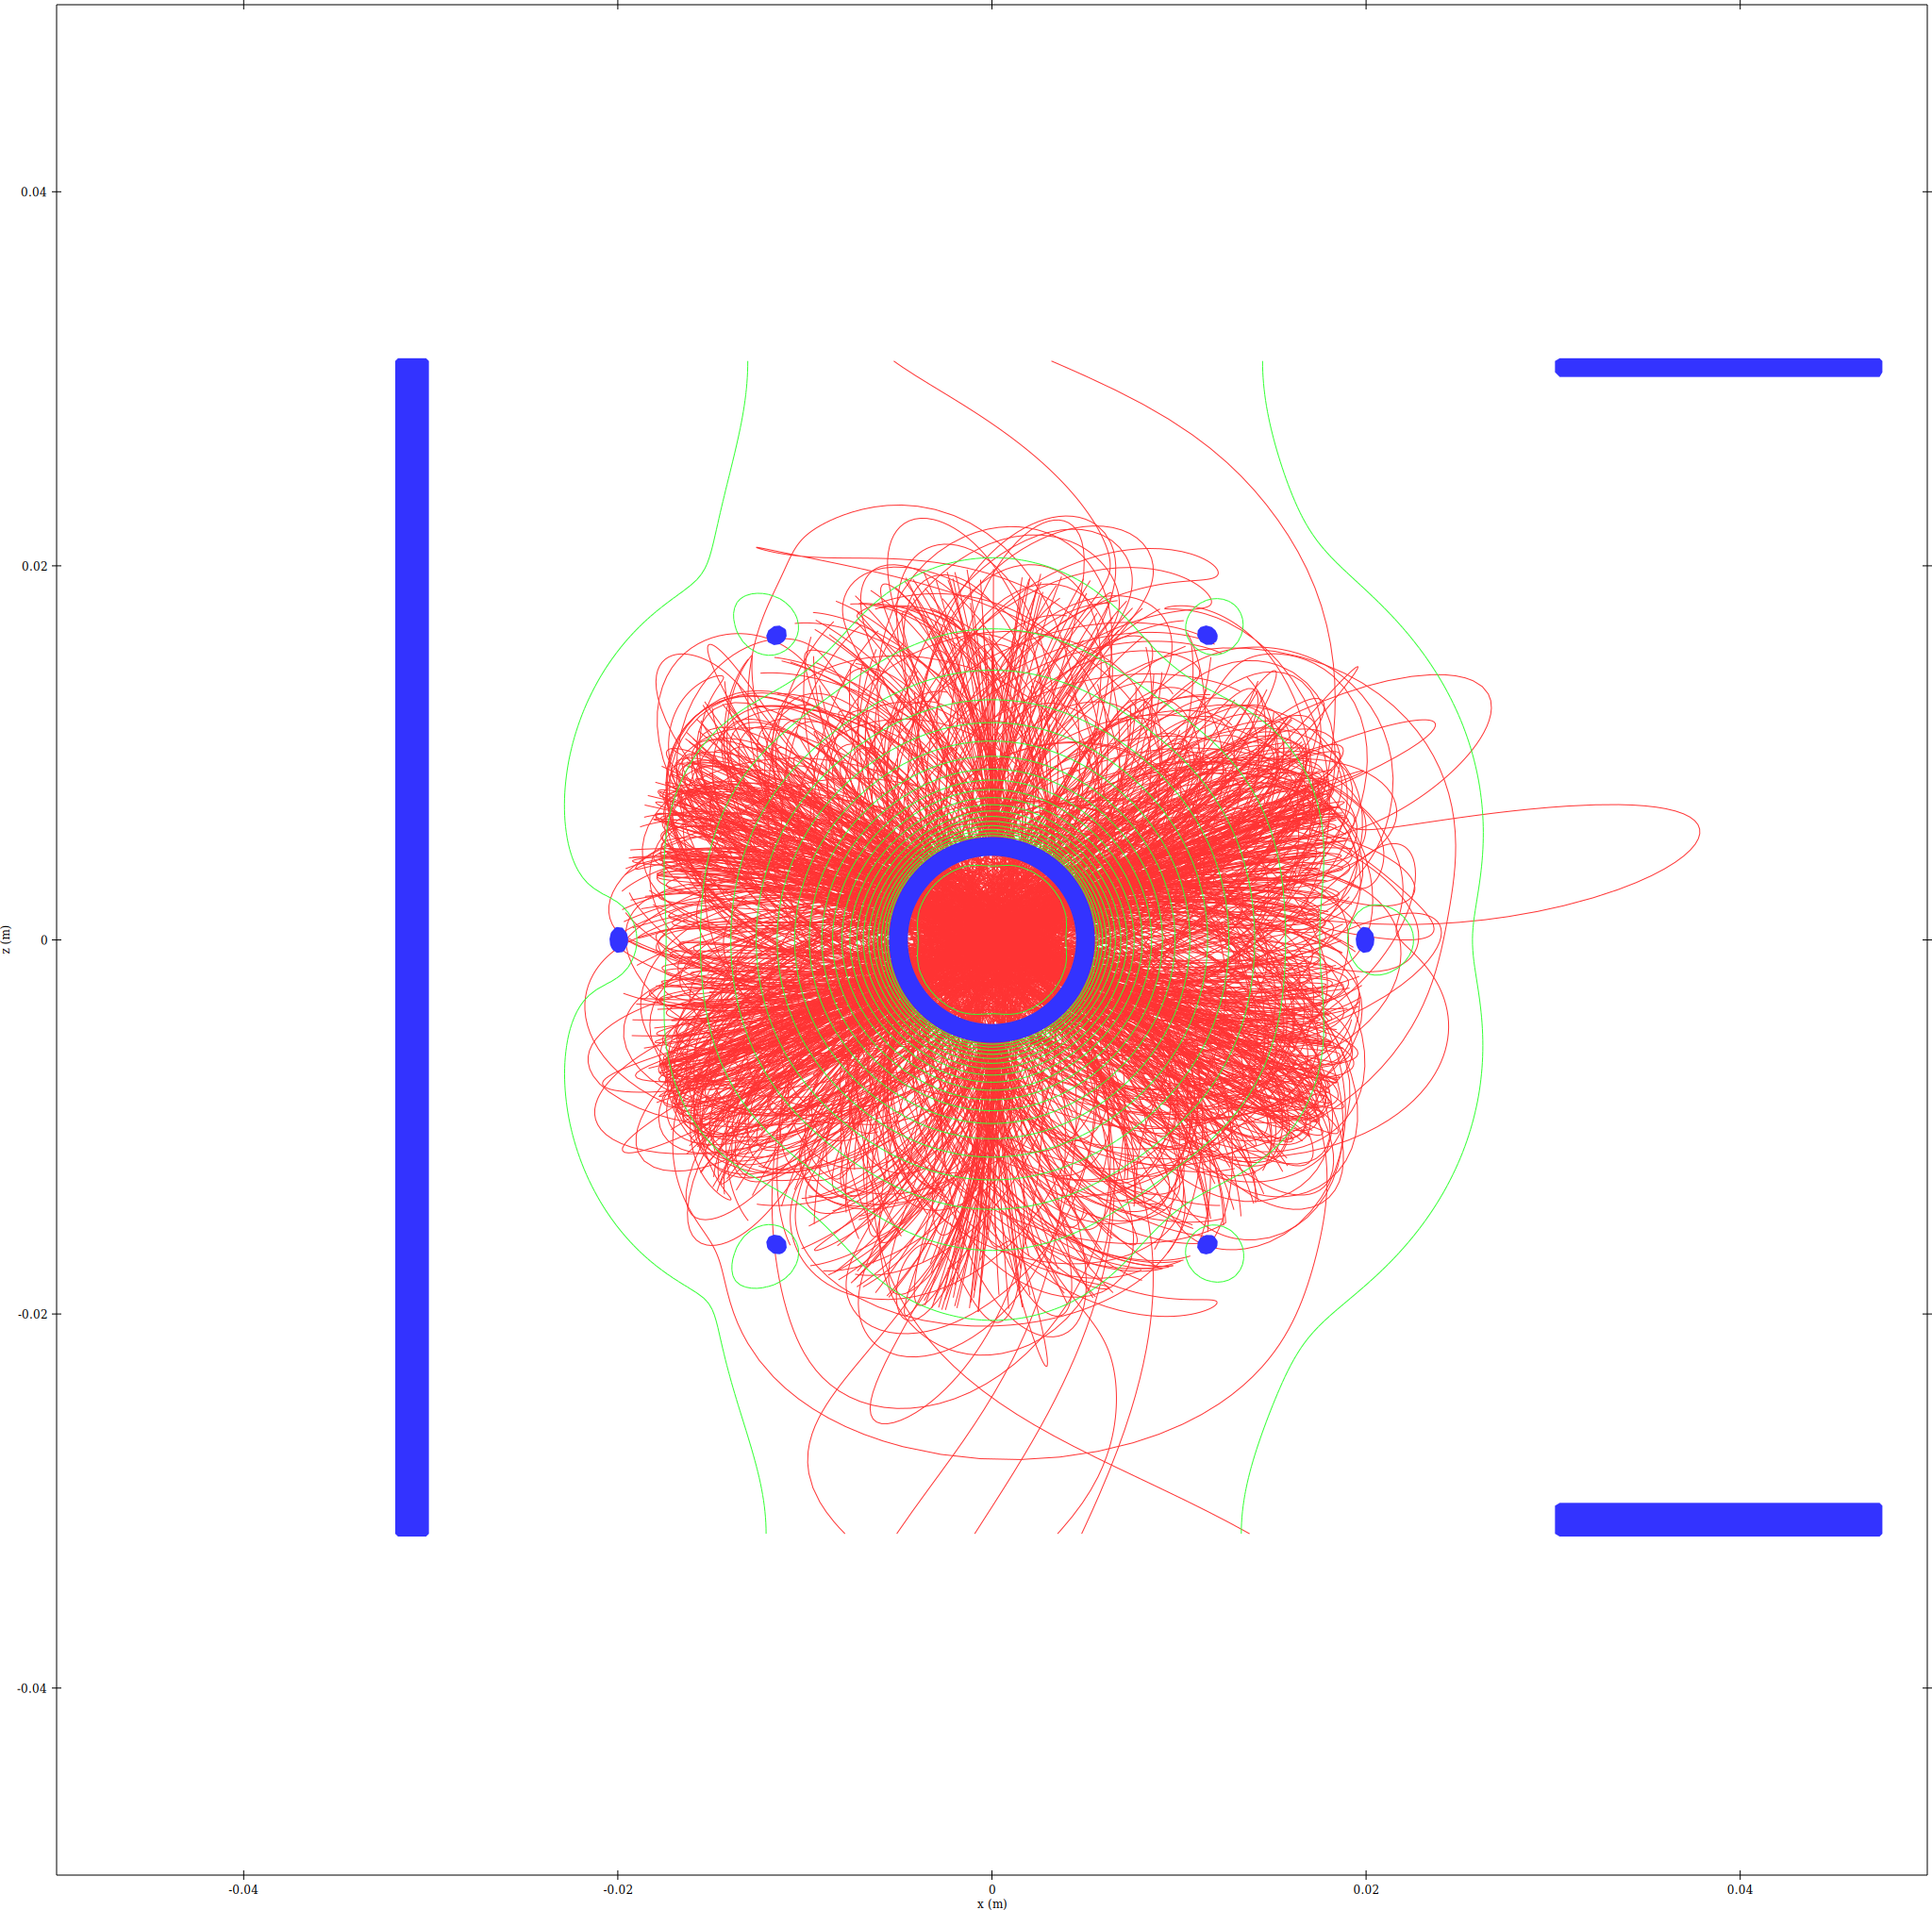 | 1 A  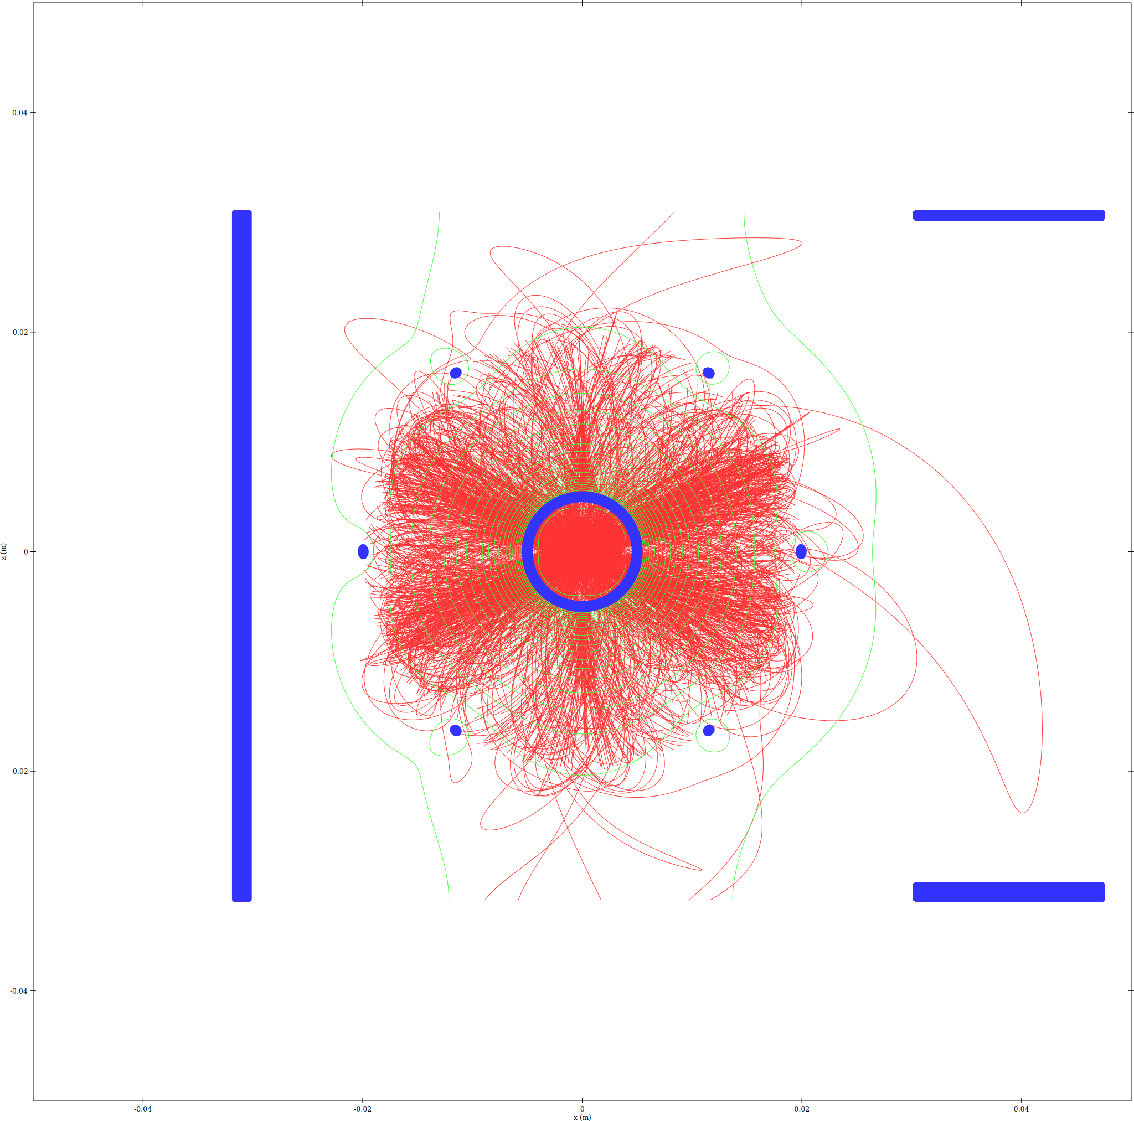
10 A  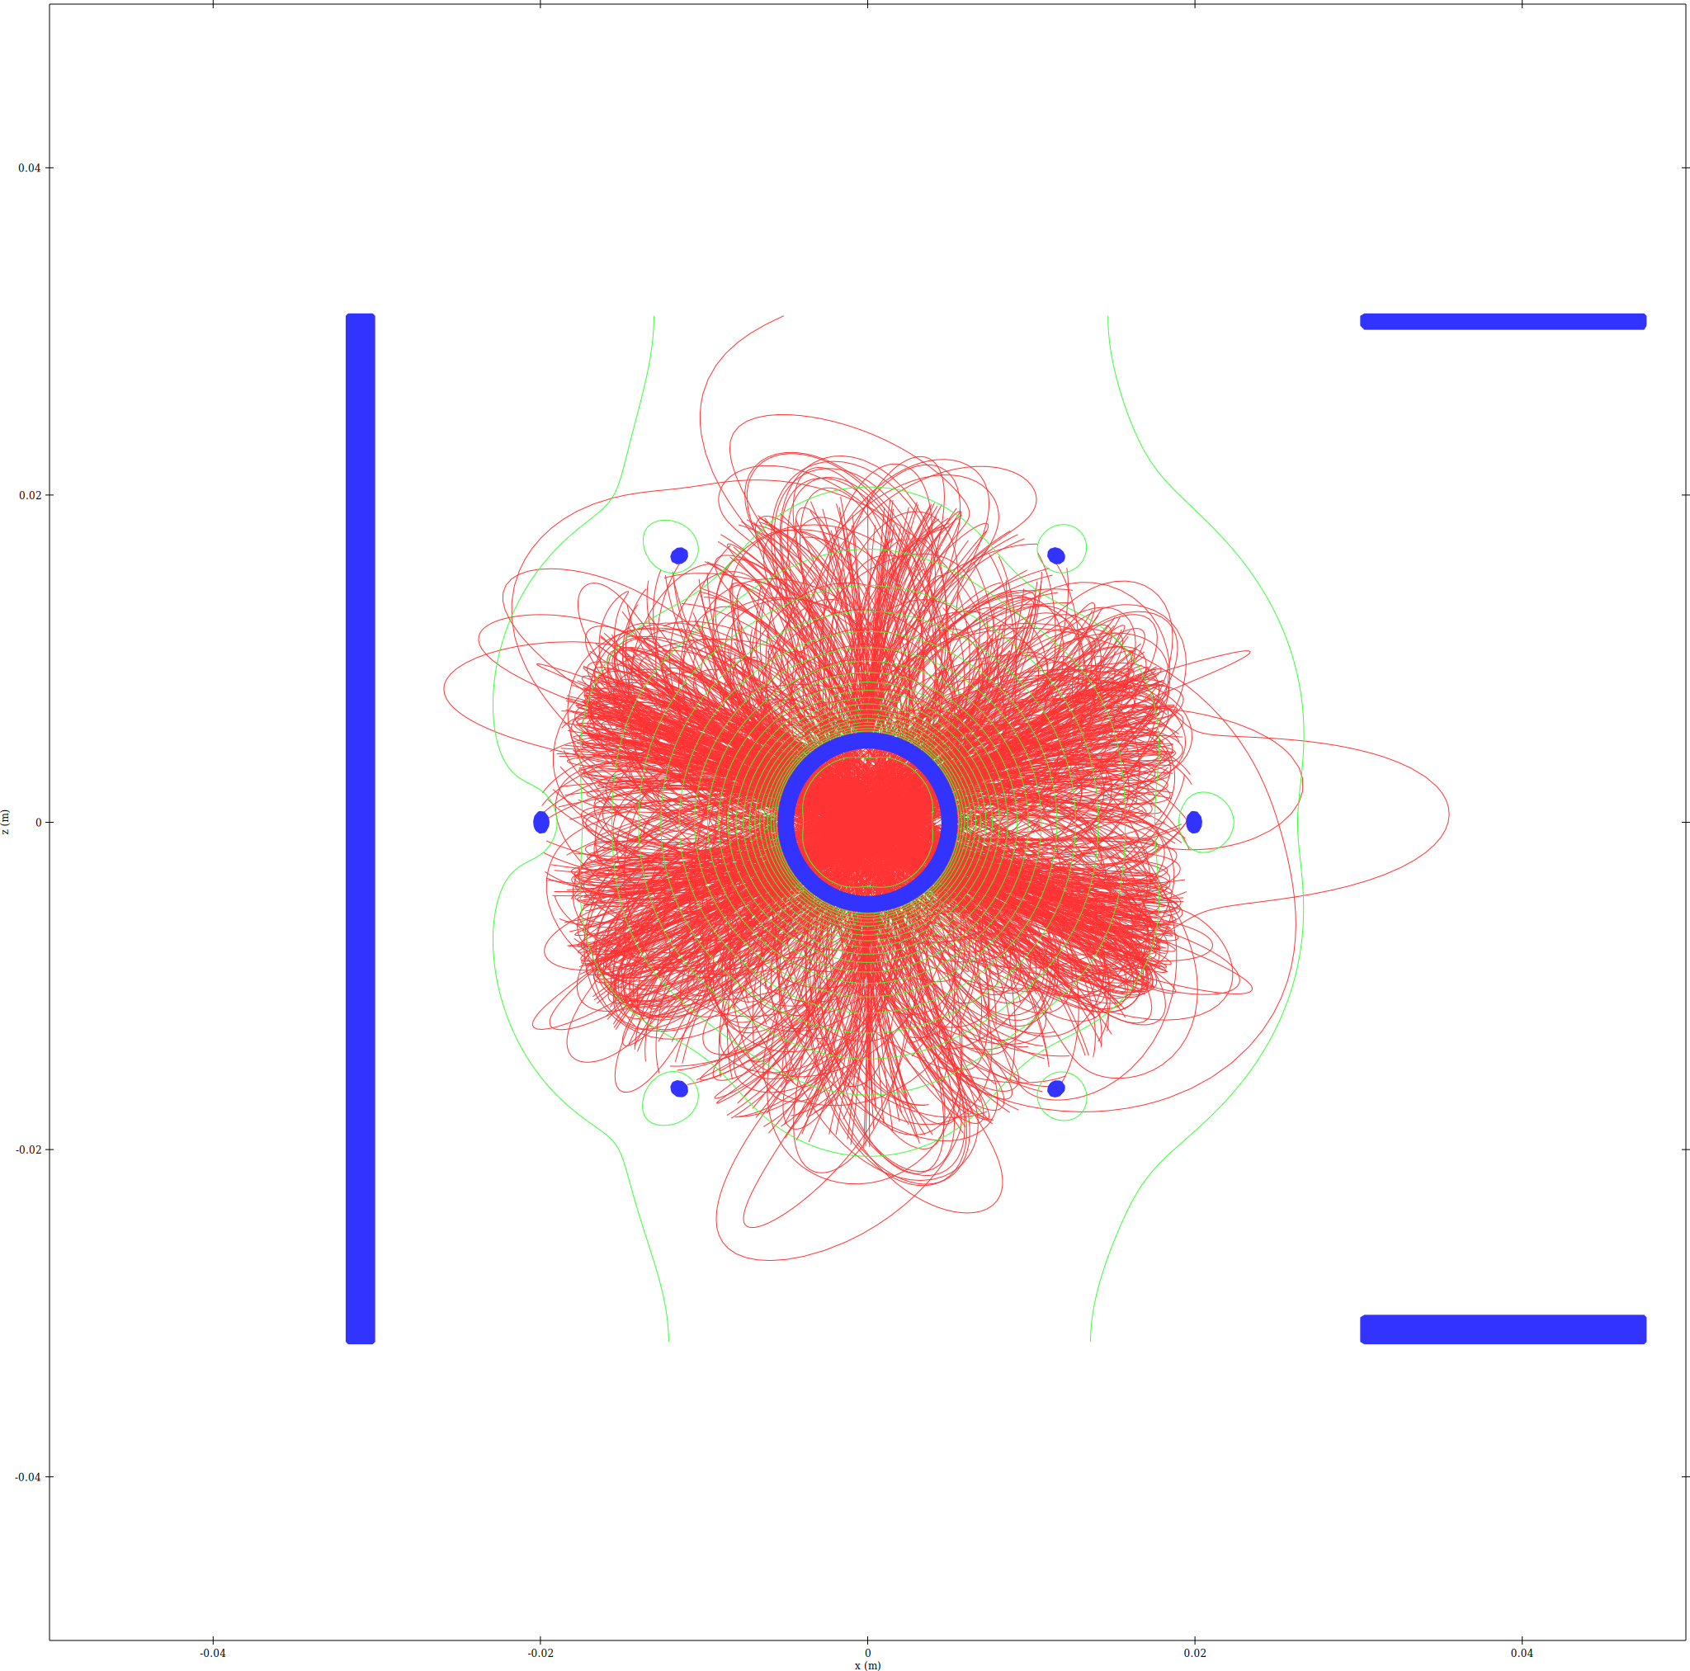 | 50 A  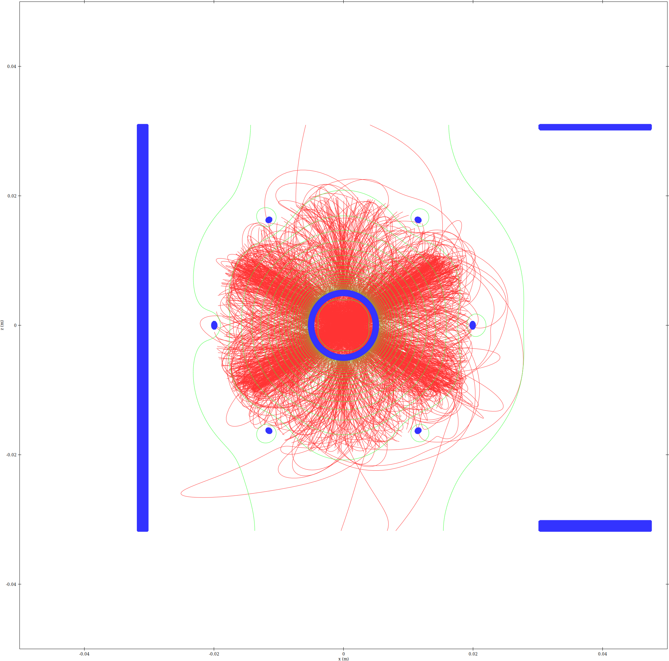

5.2 Electrons
2 mA  [missing: voltage sweep runs/run18/trajdens_electrons_xz.png] | 10 mA  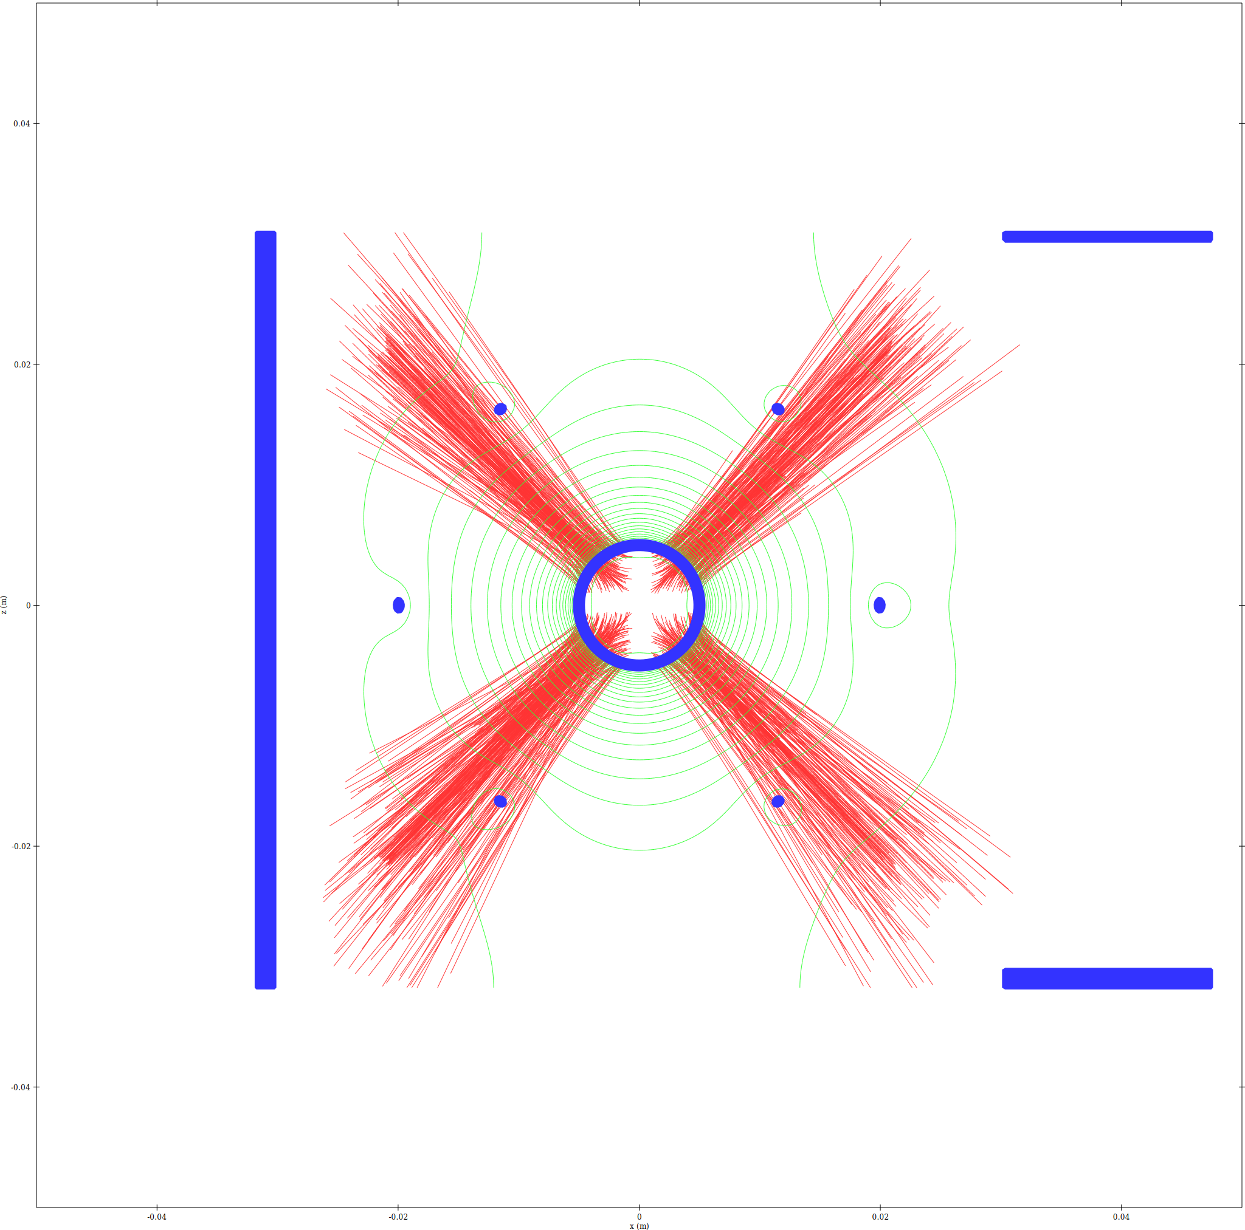
100 mA  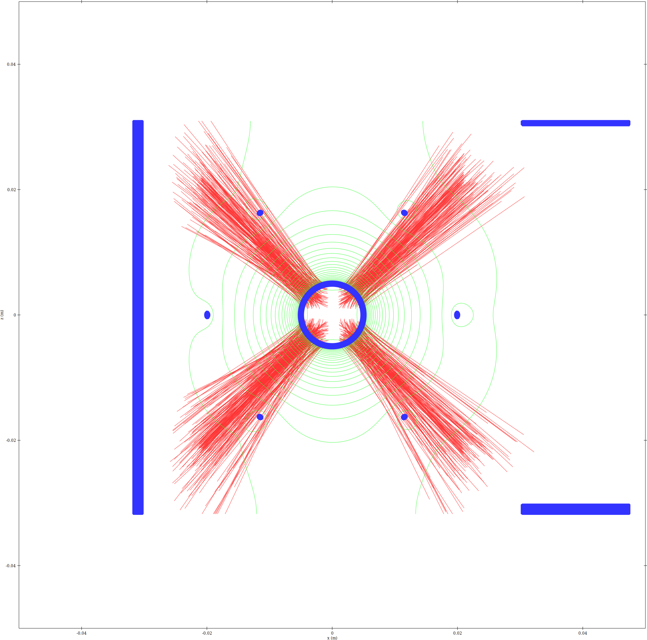 | 1 A  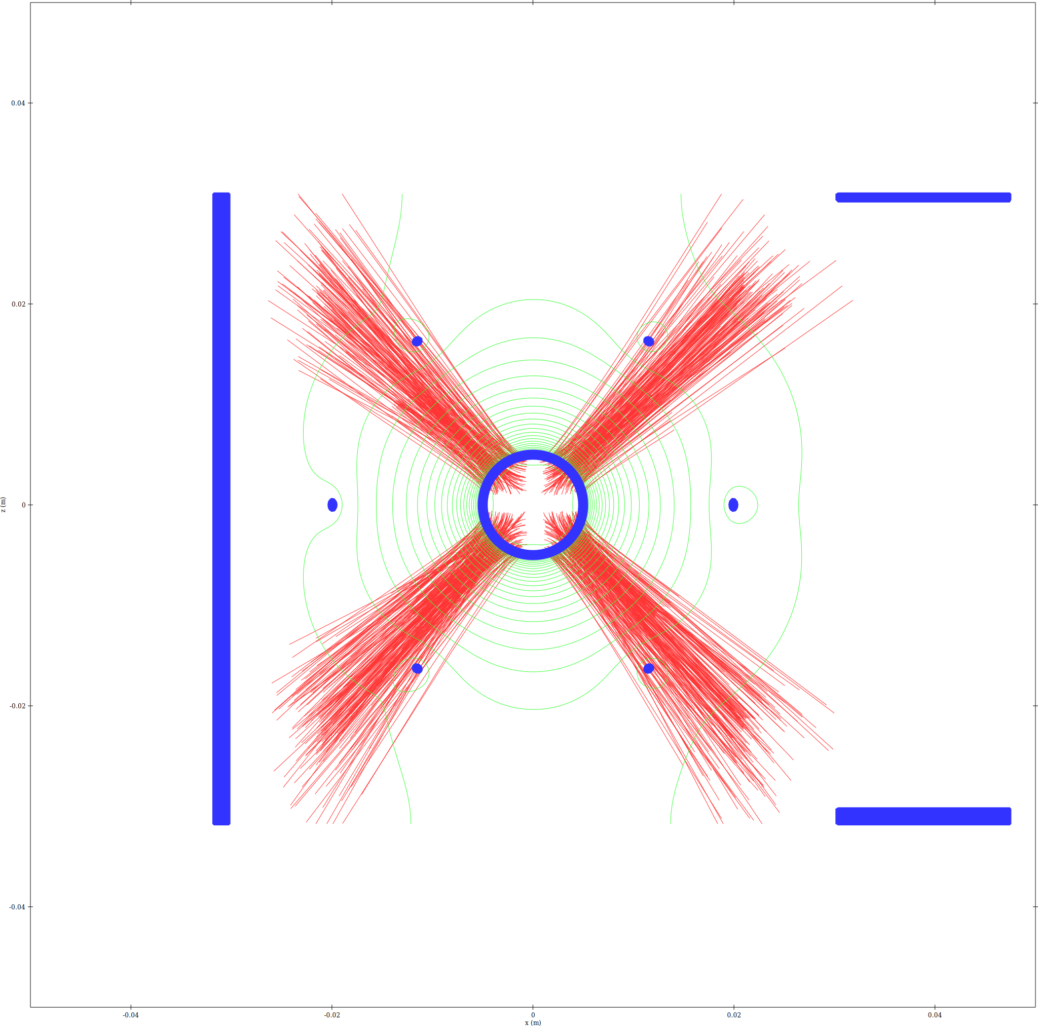
10 A  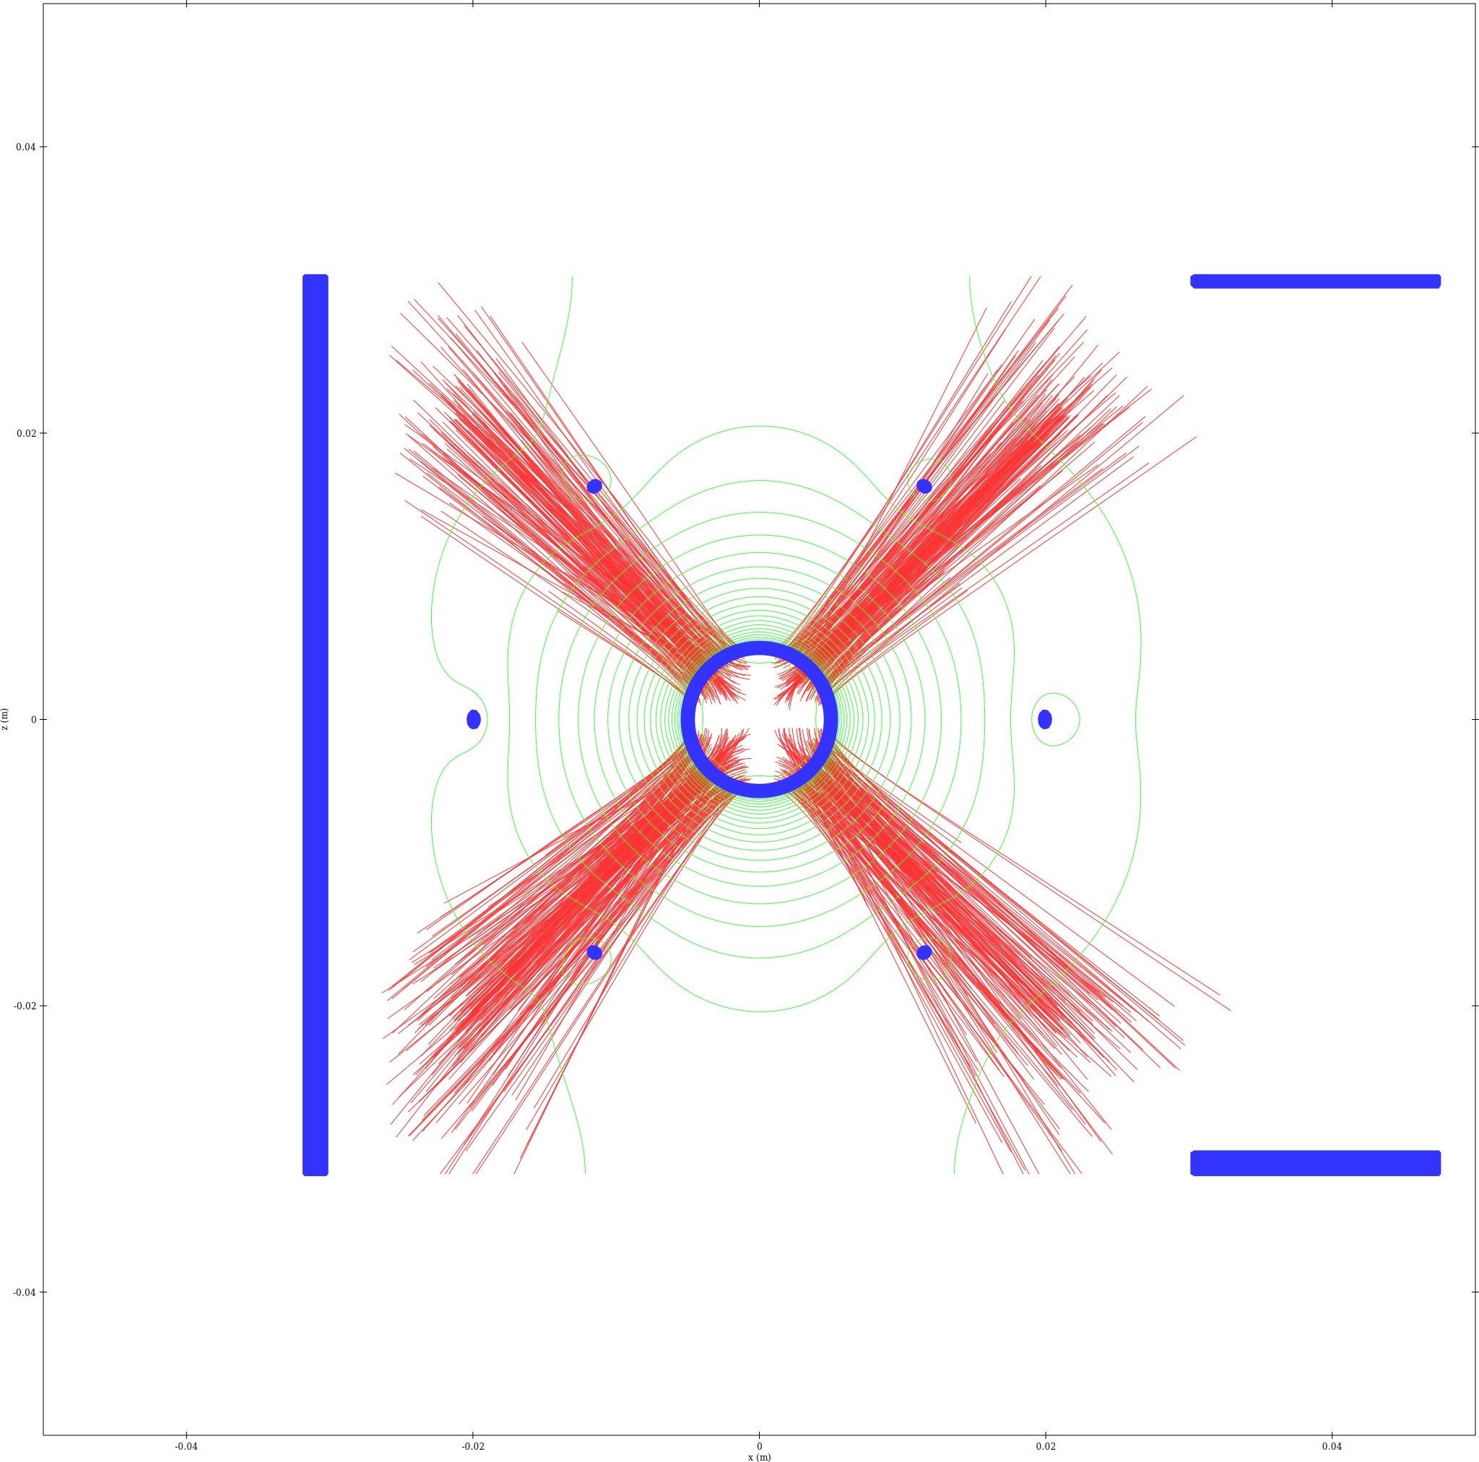 | 50 A  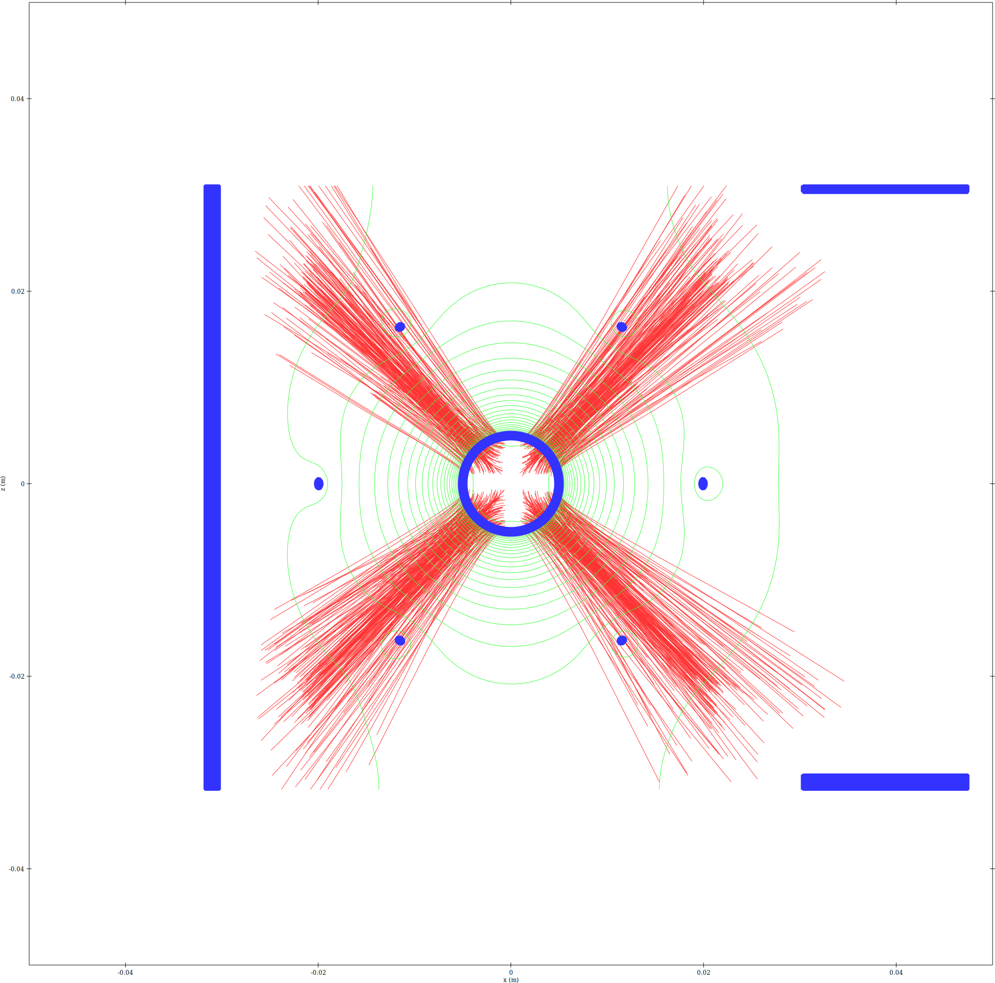

5.3 Combined (red=ions, blue=electrons, magenta=overlap)
2 mA  [missing: voltage sweep runs/run18/plots/trajdens_combined_xz.png] | 10 mA  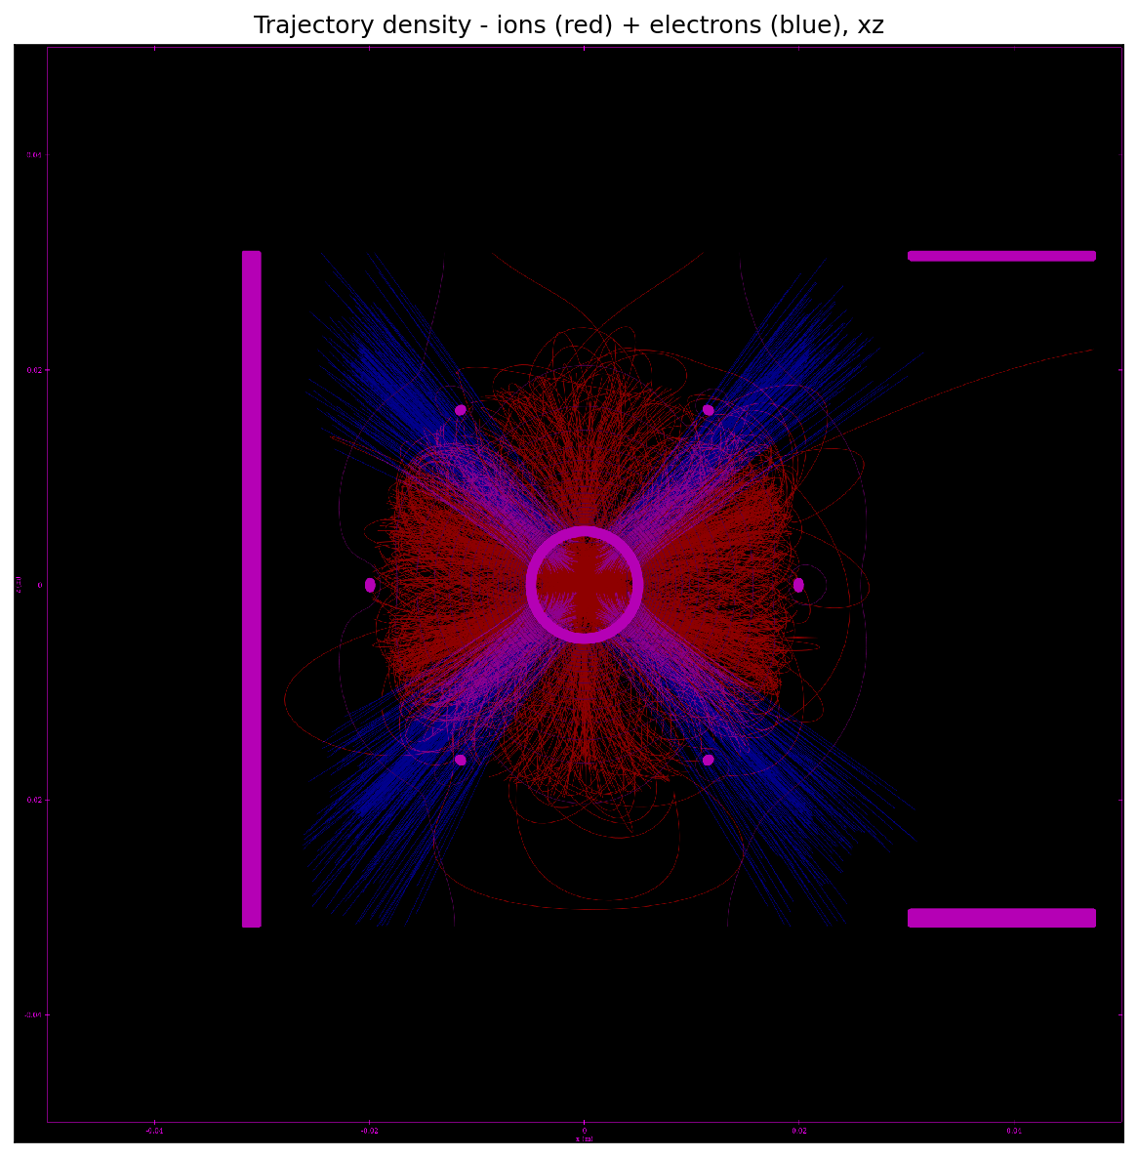
100 mA  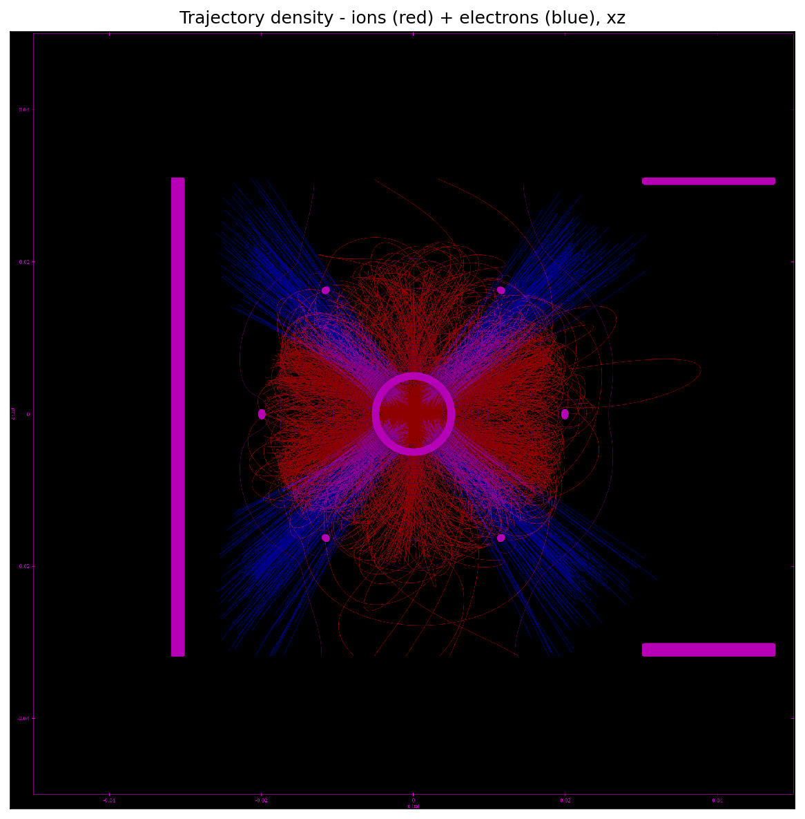 | 1 A  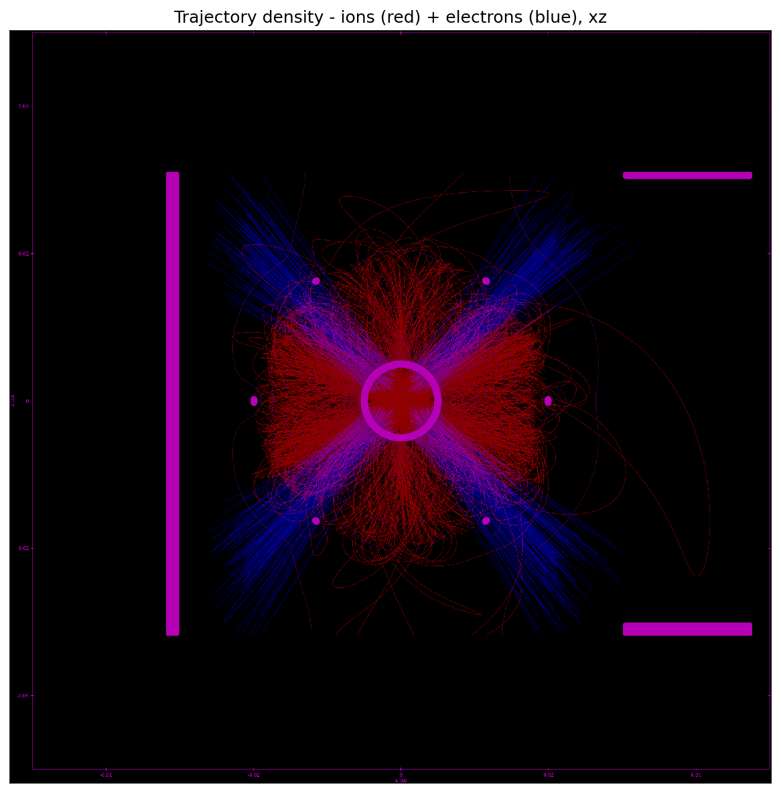
10 A  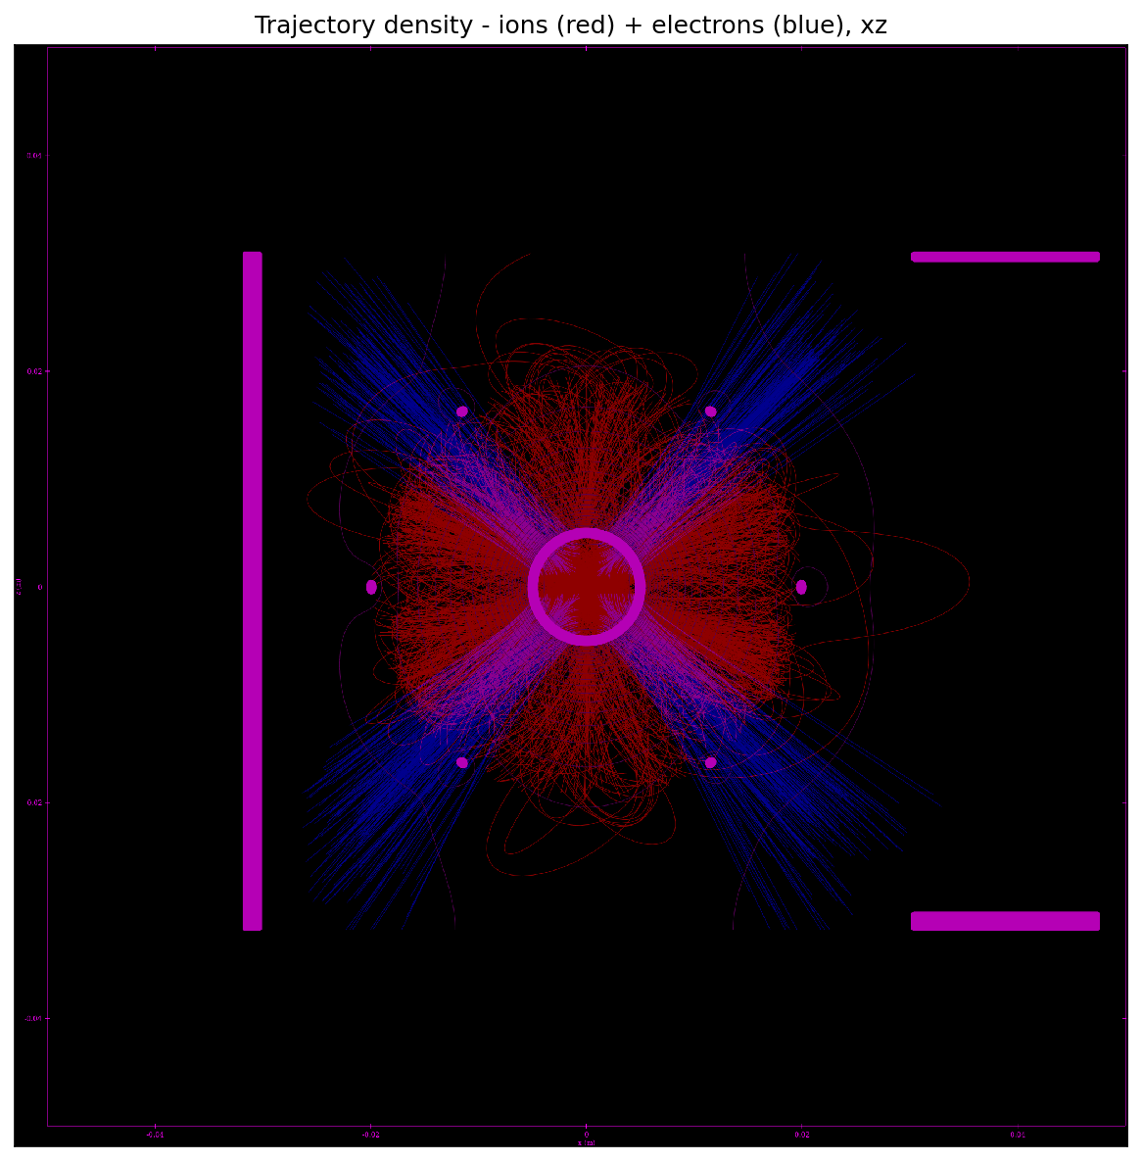 | 50 A  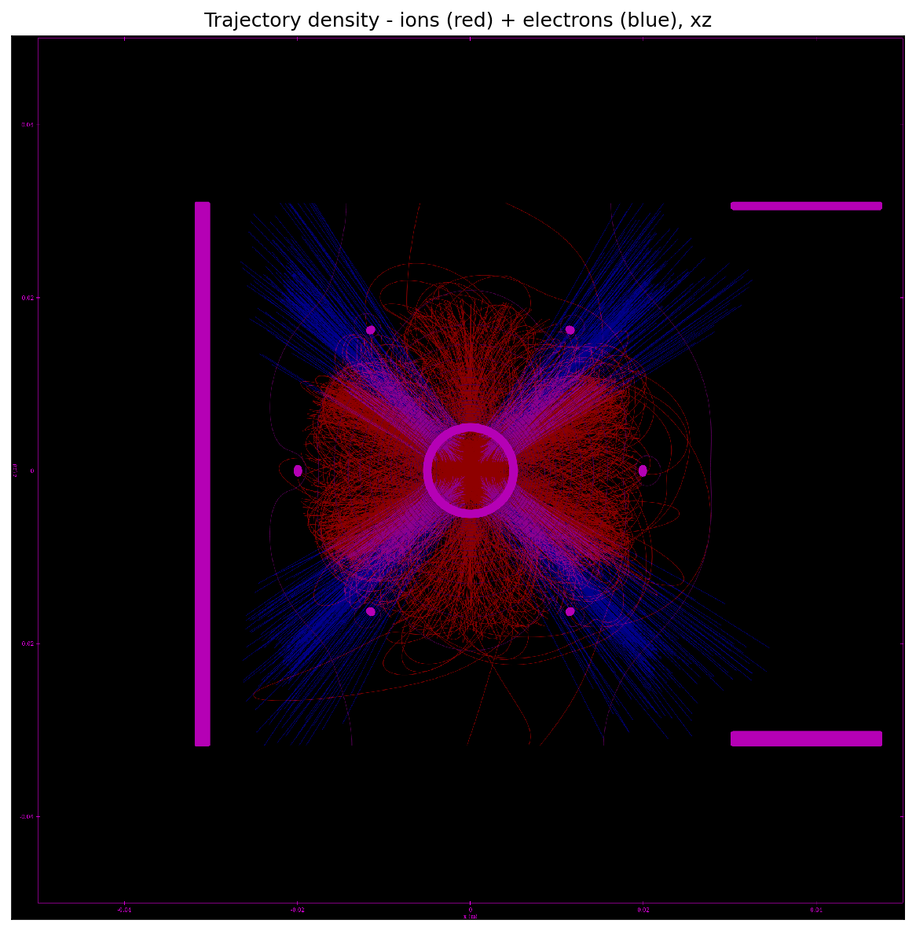

6. Final Potential Field Comparison (epot_xz)
2 mA  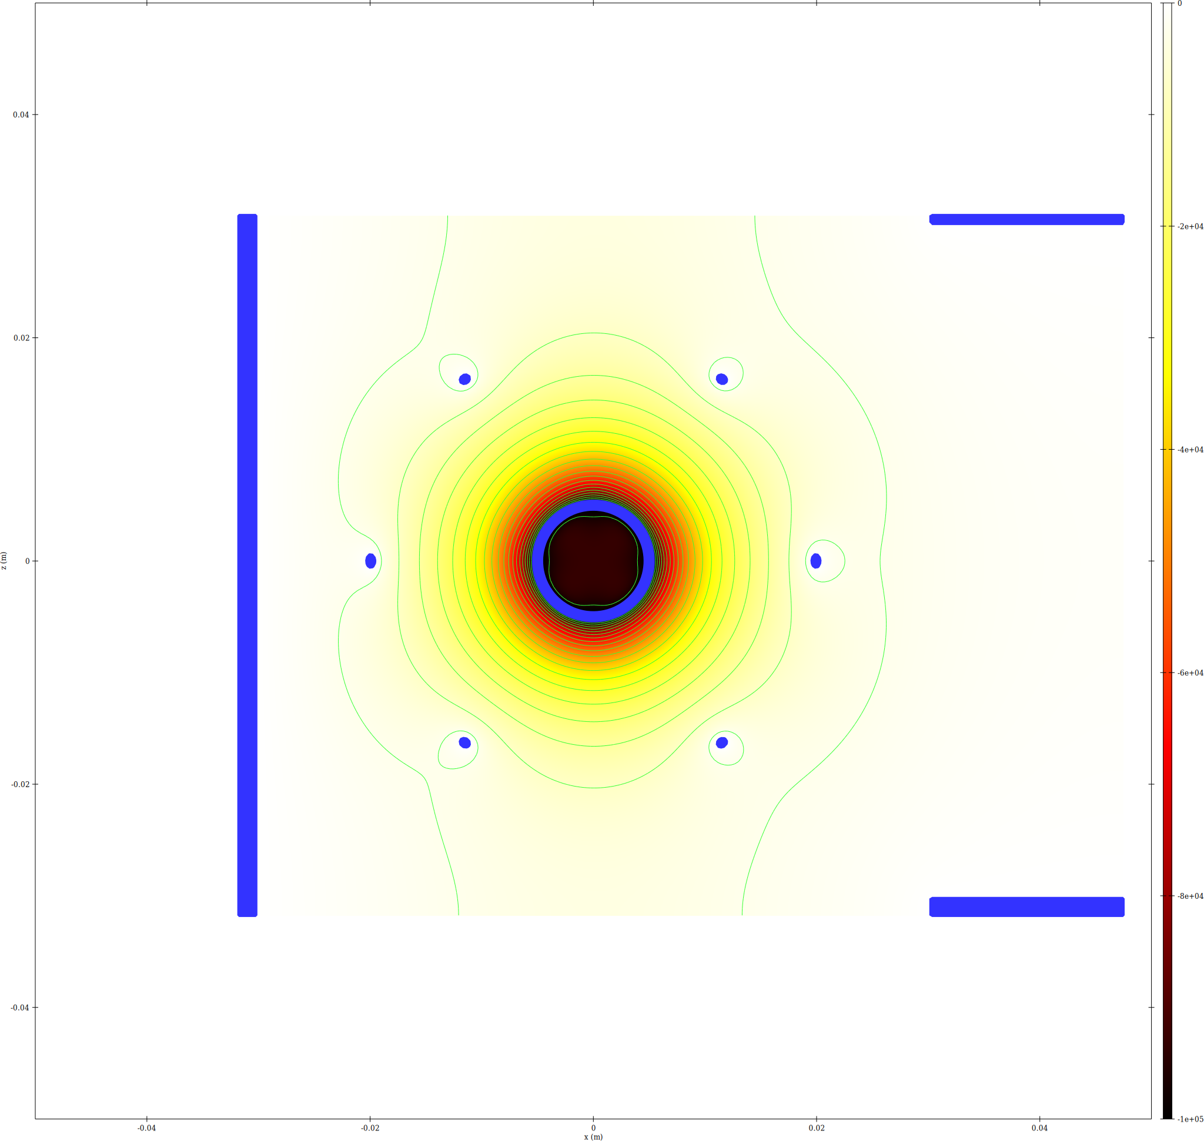 | 10 mA  
100 mA   | 1 A  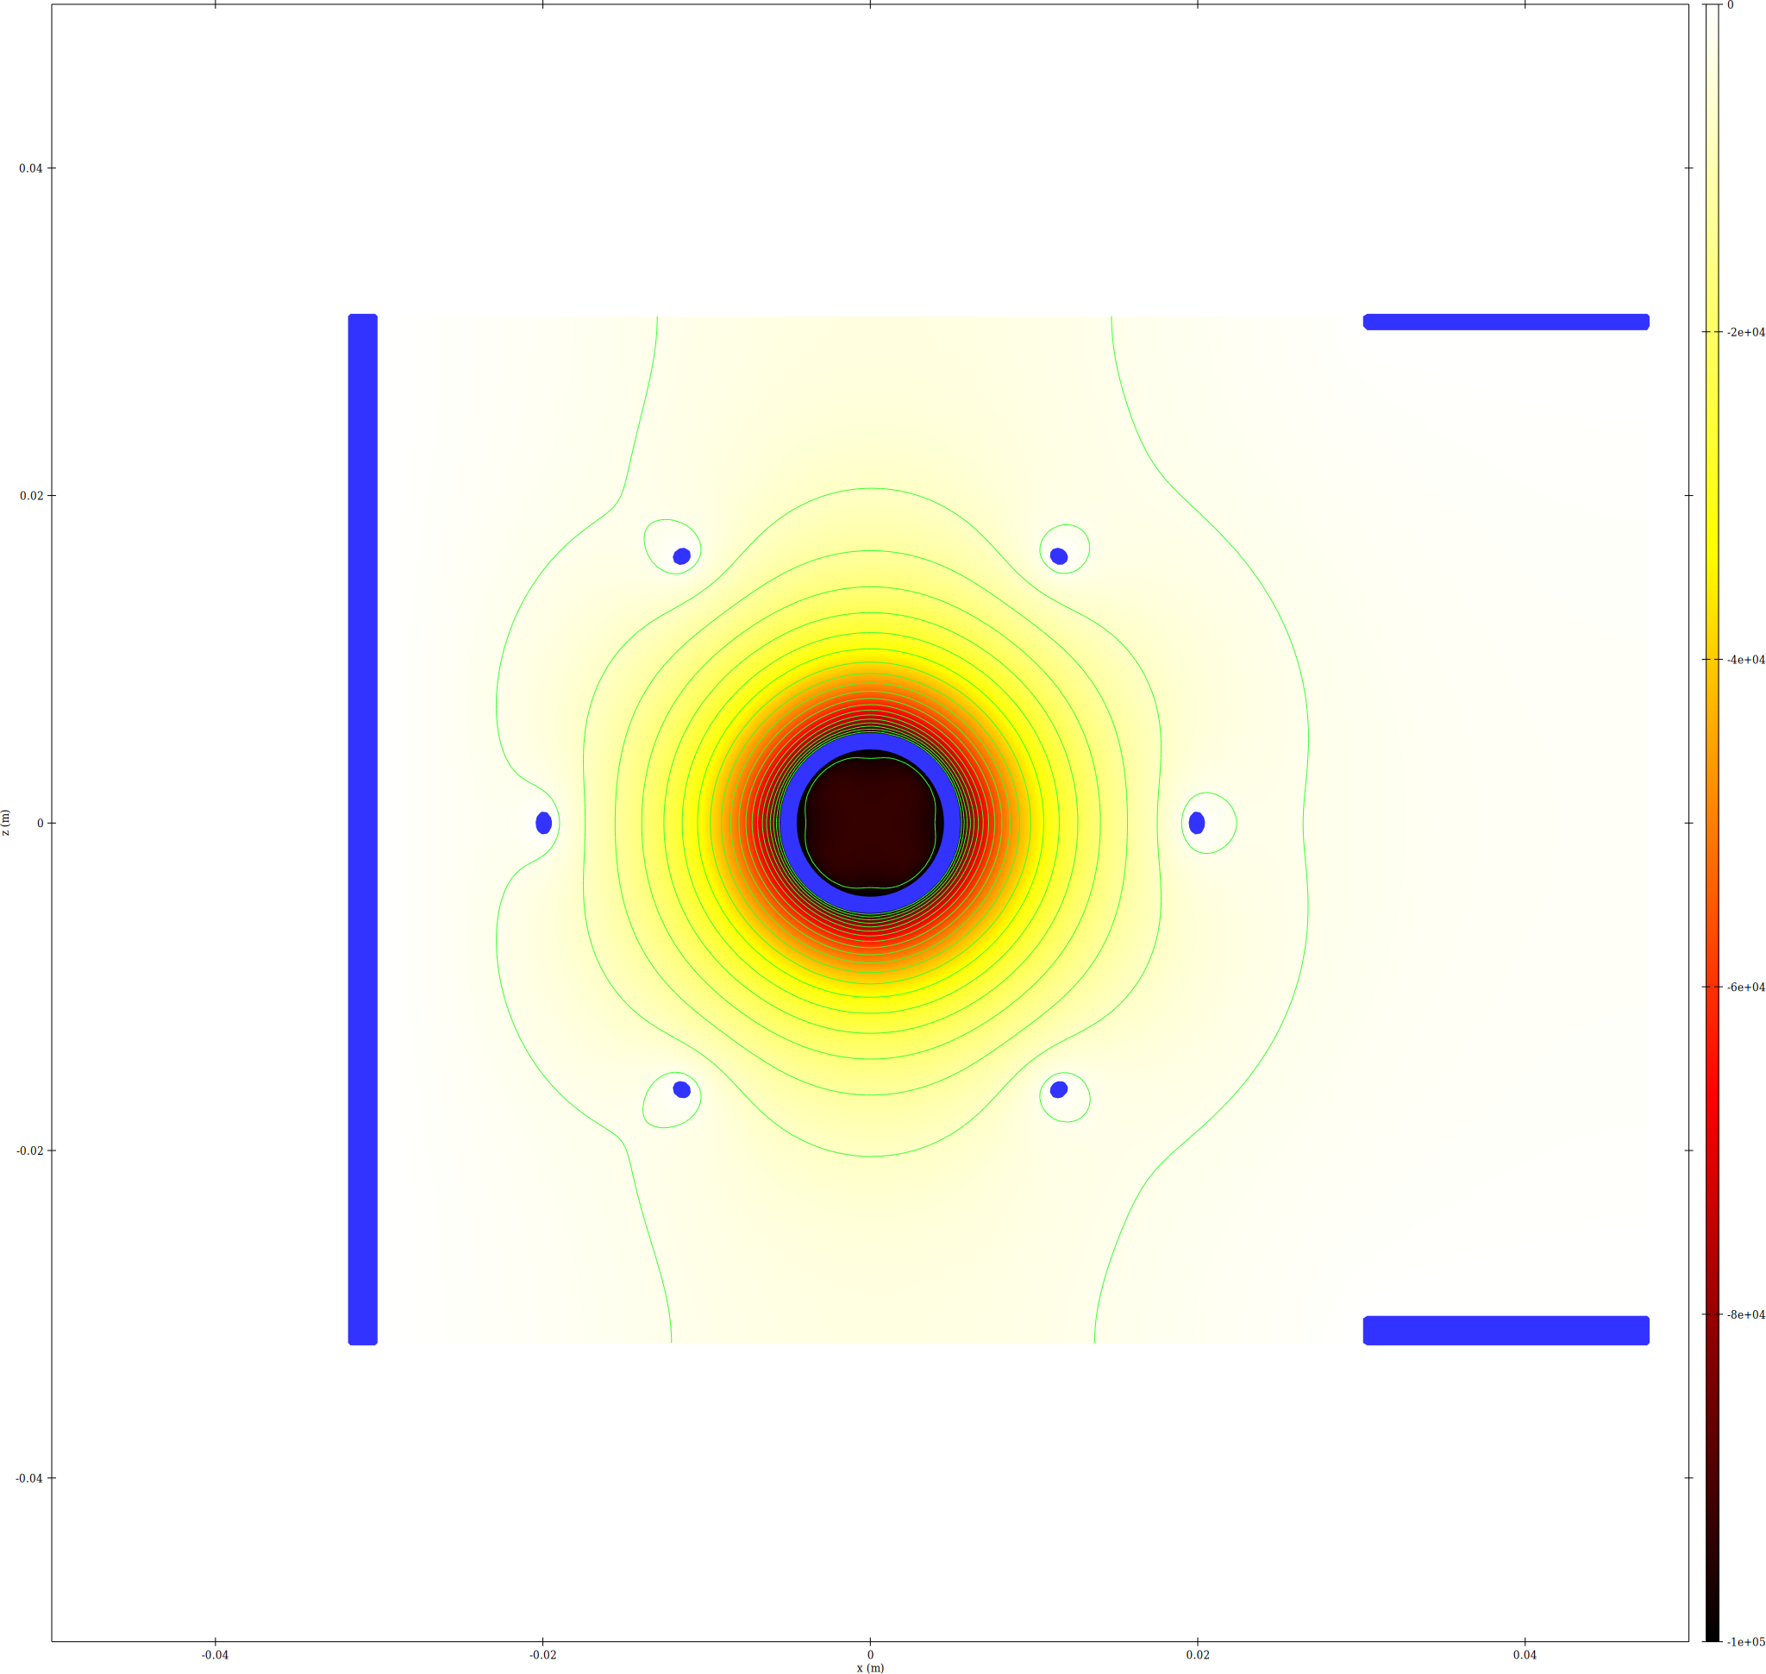
10 A  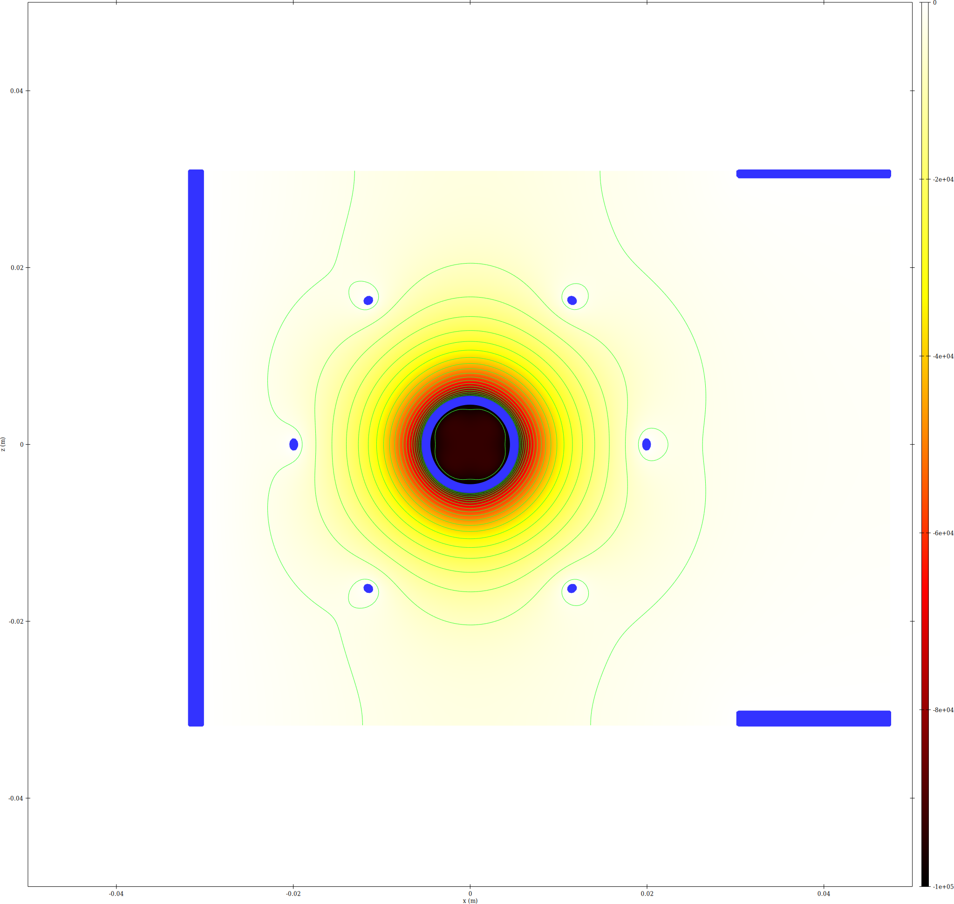 | 50 A  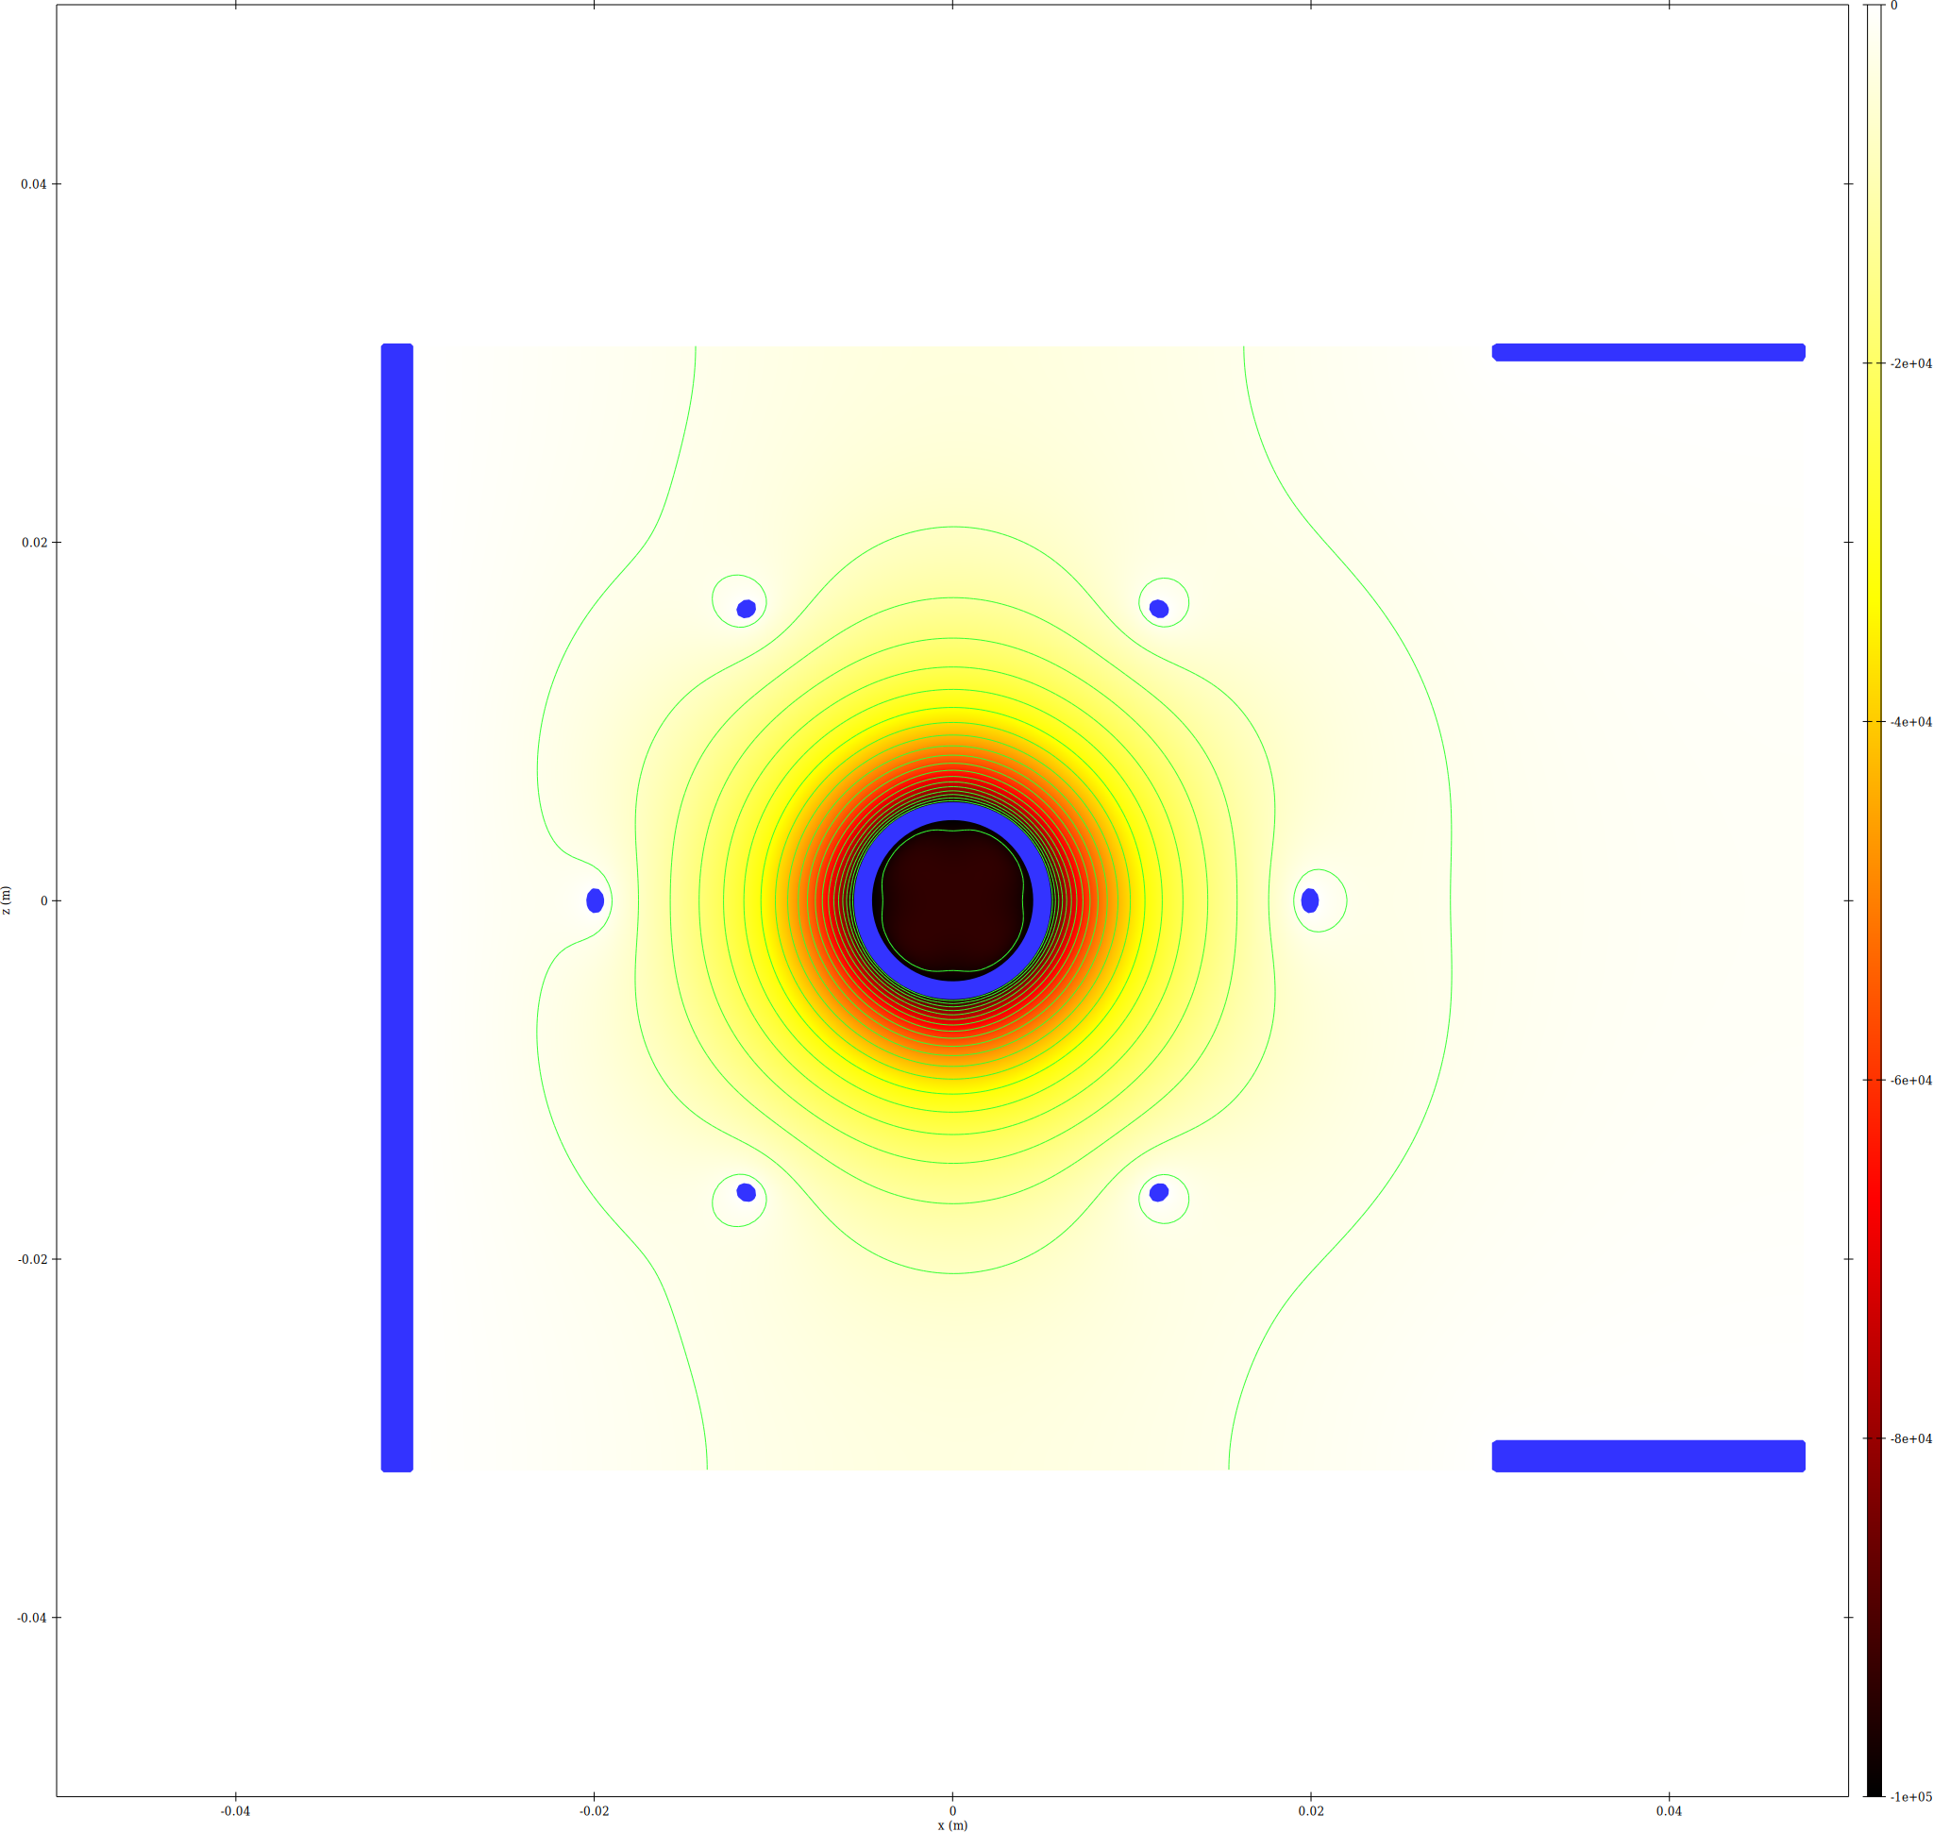

7. Memory Summary
Run | Current | Final iter | Ion steps | Electron steps | Total GB
run18 | 2 mA | 2 | 81787441 | 31853037 | 8.9404
run19 | 10 mA | 2 | 81565366 | 31872241 | 8.9298
run20 | 100 mA | 2 | 81771214 | 31854741 | 8.9396
run21 | 1 A | 5 | 81704920 | 31945301 | 8.9409
run22 | 10 A | 5 | 82919989 | 33860724 | 9.1041
run23 | 50 A | 6 | 90061137 | 41327225 | 9.8660

8. Perveance Analysis
Run | Current | K | vs threshold K=0.34 | Anode height change vs baseline
run18 | 2 mA | 0.002 | 170x below | -0.0001%
run19 | 10 mA | 0.01 | 34x below | -0.0001%
run20 | 100 mA | 0.1 | 3.4x below | -0.0001%
run21 | 1 A | 1 | 2.941x above | -0.0094%
run22 | 10 A | 10 | 29.41x above | -0.1041%
run23 | 50 A | 50 | 147.1x above | -0.4950%

9. Step-count and Cap Diagnostic vs Current
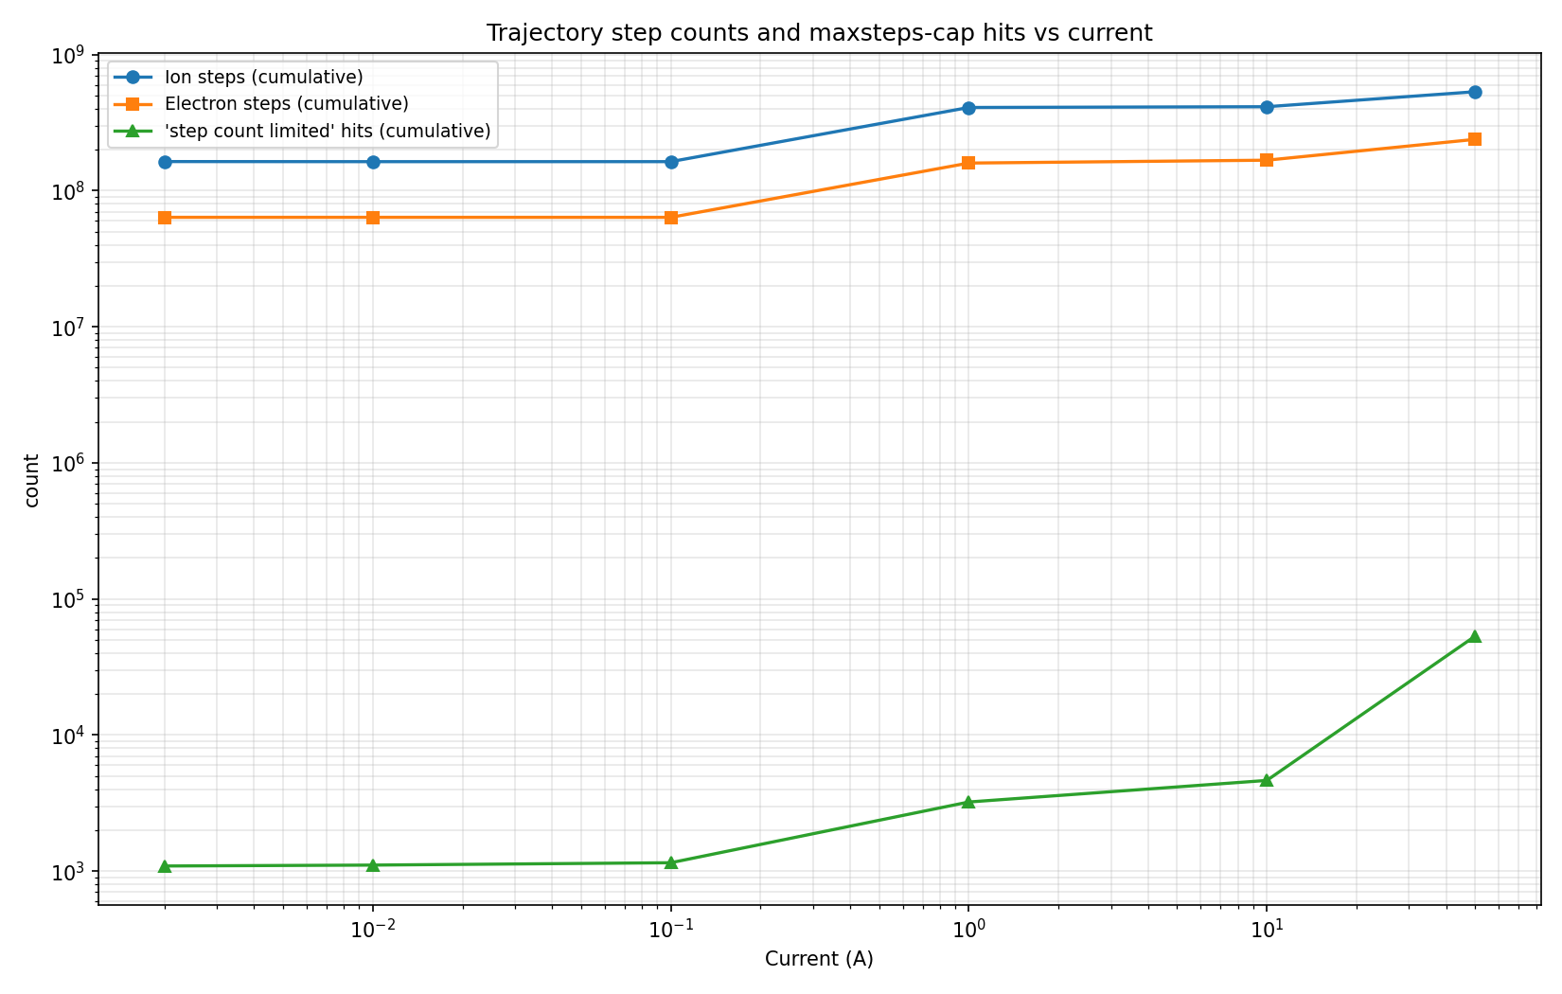
Log-log plot of cumulative trajectory steps and IBSimu 'step count limited' (maxsteps=1000 cap) hits across all iterations of each run. Cap hits growing super-linearly with current indicates space-charge trapping is starting to matter.

